ACCOUNT SETTINGS

AUTHOR WASHINGTON AWALA

Purpose
The purpose of this document is to provide a visual guide on how to edit profile information and changing password.
Prerequisites
You must be logged in SBRL account.

PROFILE EDIT

Steps of editing profile:
1. On the dashboard page, at the top right click the toggle menu then click profile.
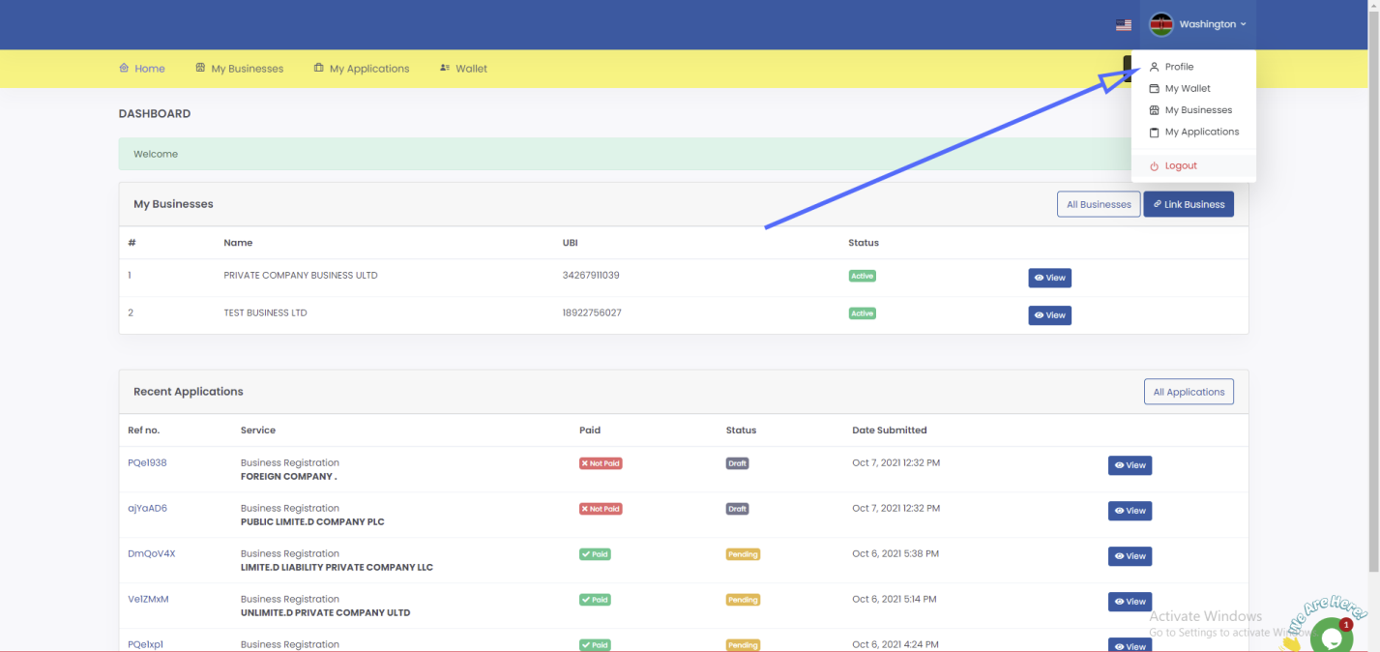

2. On the profile page click edit button (at the top right)
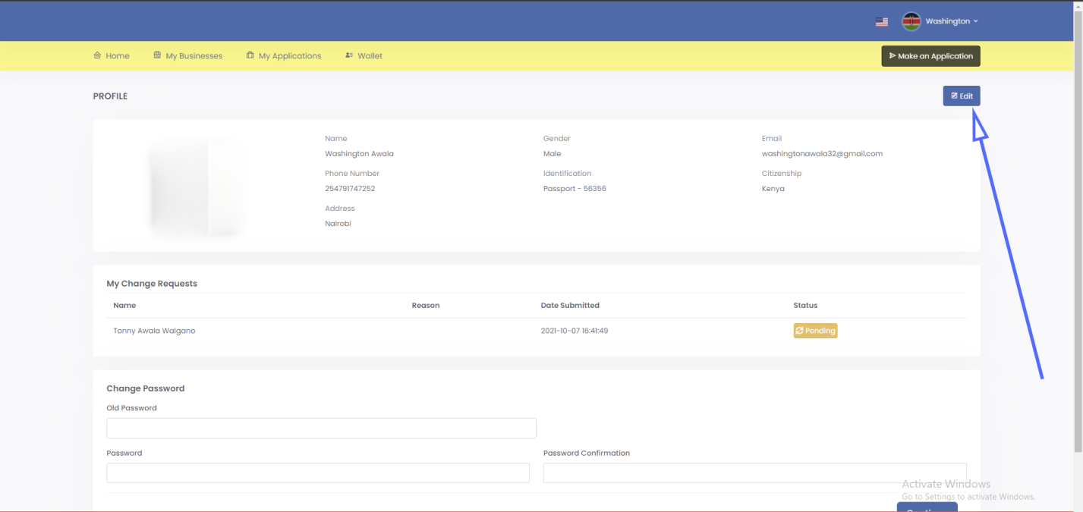

3. Edit respective field then click submit.
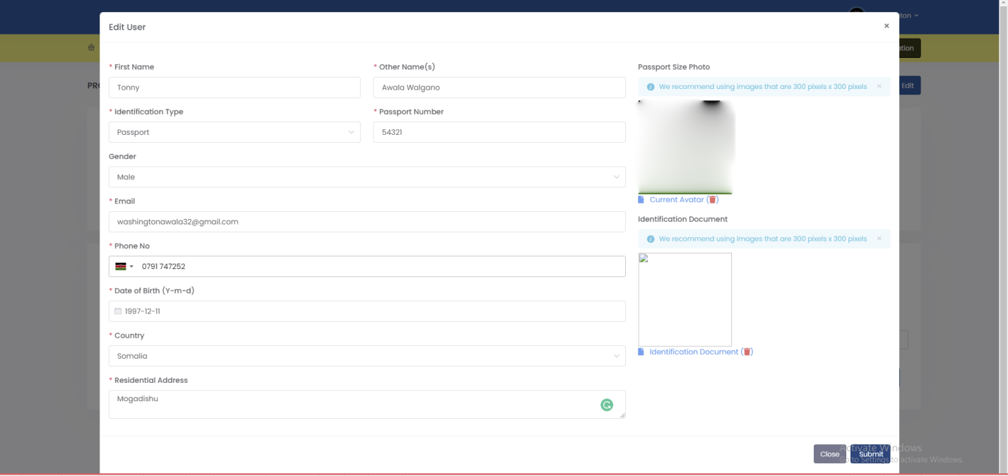

On a successful profile edit a success alert will pop up. You will be required to keep checking your SBRL account to find out whether your profile edit request was approved. Usually, it takes 1 business day.
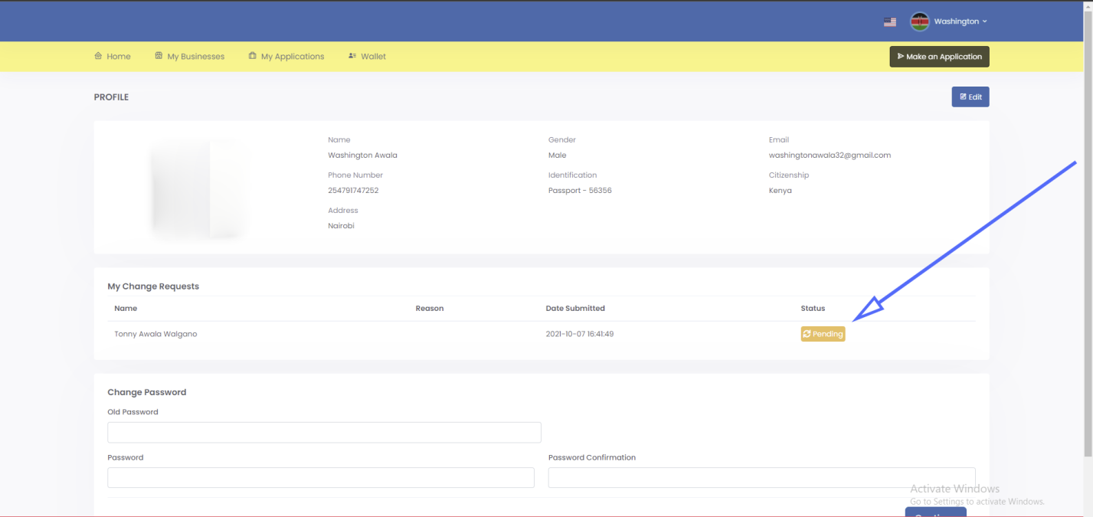

CHANGE PASSWORD

Steps of editing profile:
1. On the dashboard page, at the top right click the toggle menu then click profile.

2. On the profile page scroll down to the password editing form, enter old password(your current password), enter new password and password confirmation then click continue.
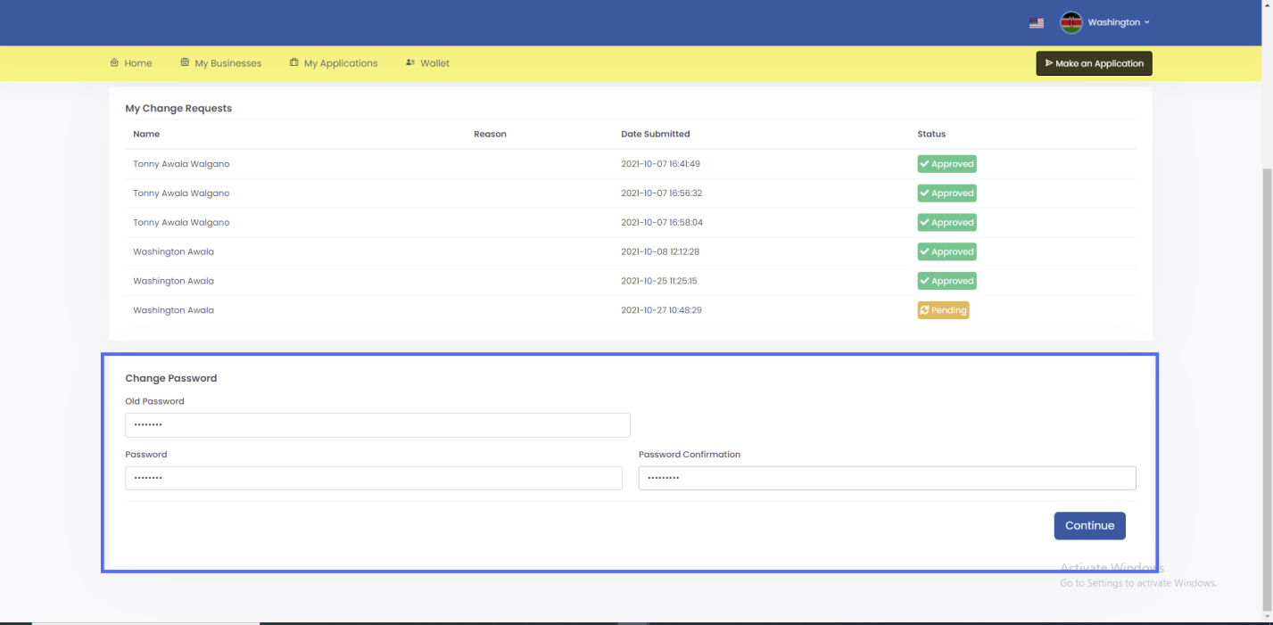

On a successful password change a you’ll be logged out then redirected to the login page where you’ll be required to sign with your new password.
