AUTHENTICATION

AUTHOR WASHINGTON AWALA

Purpose
The purpose of this document is to provide a visual guide on how to sign up, sign in sign out and reset password of a SBRL account.

SIGN UP

Steps of sign up:
1. Go to the registration page, enter your email then click continue.
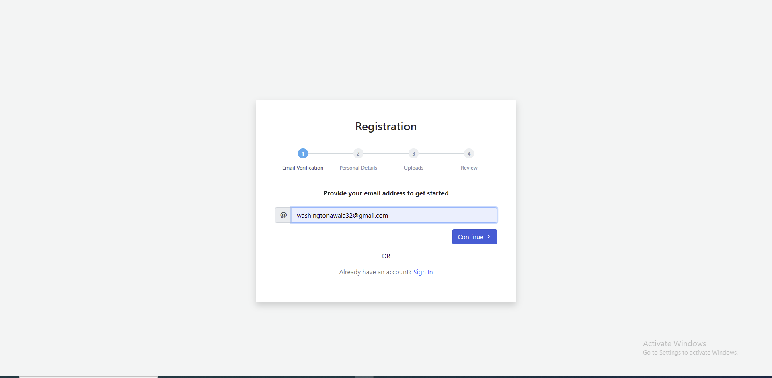

2. Enter the verification code sent to your email then click submit
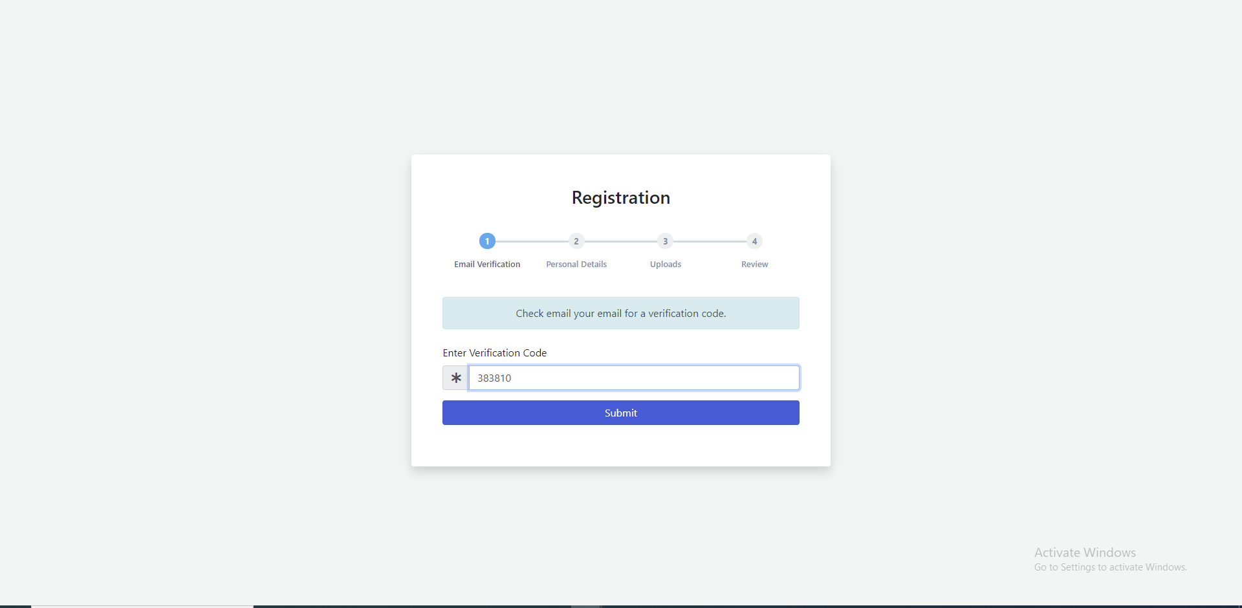

3. Enter name, select passport and enter passport number, select country, enter date of birth, enter phone number select gender, enter residential address then click continue.
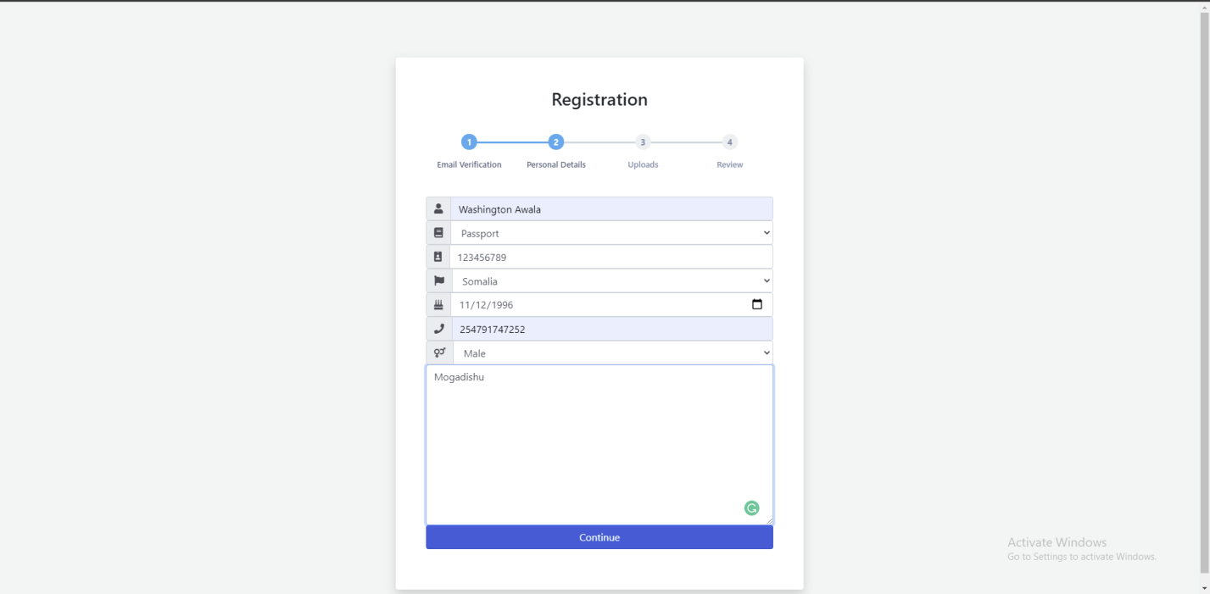

4. Upload the identification documents then click submit.
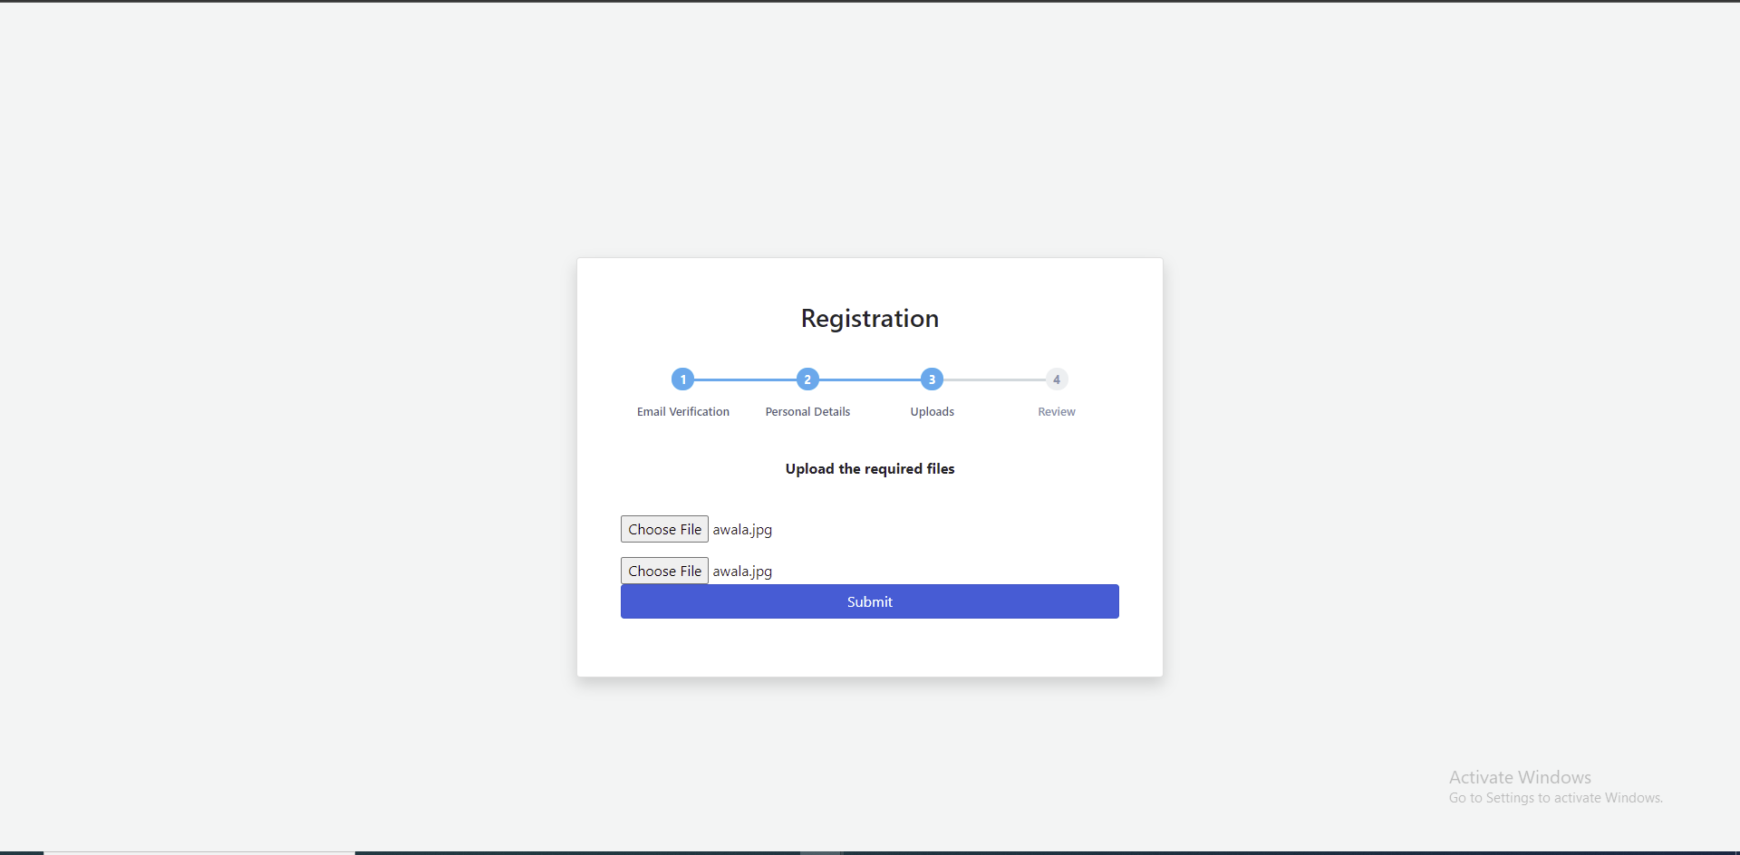

5. Review information then click submit
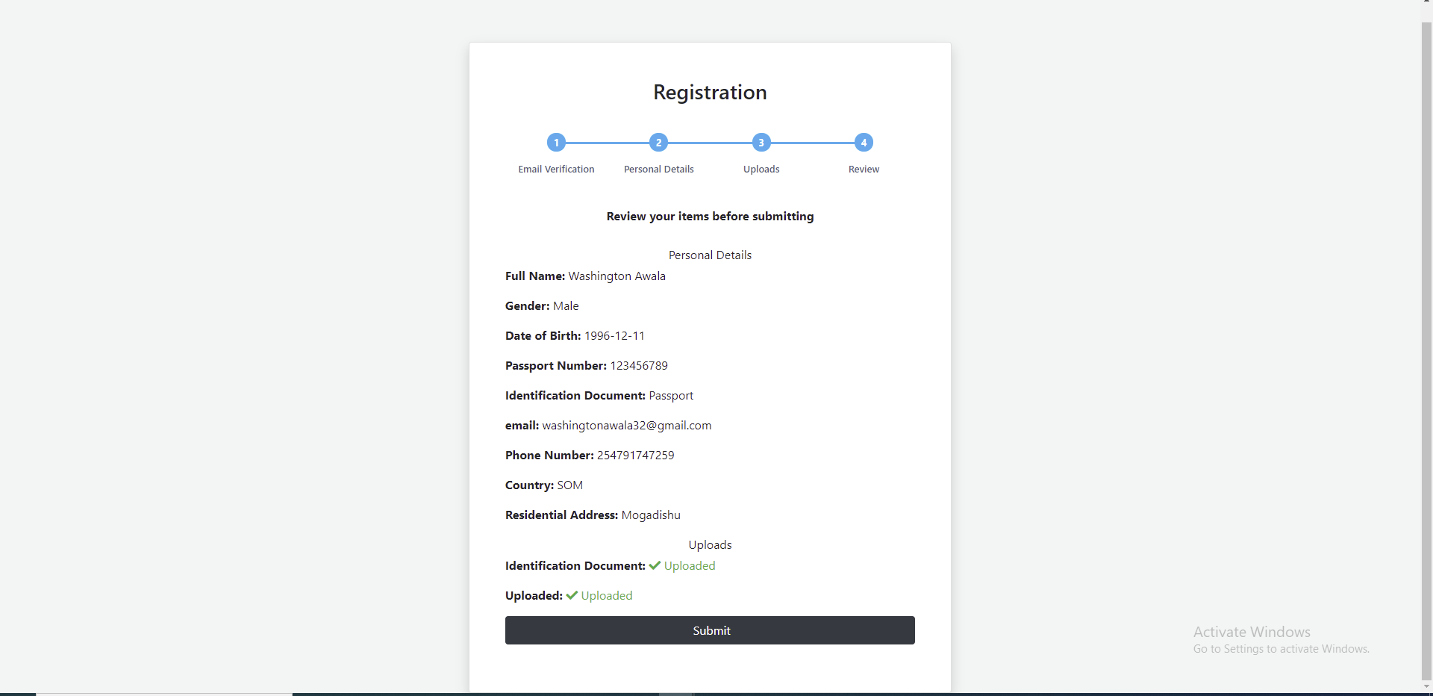

6. Once your registration request has been submitted successfully you will see the page below.
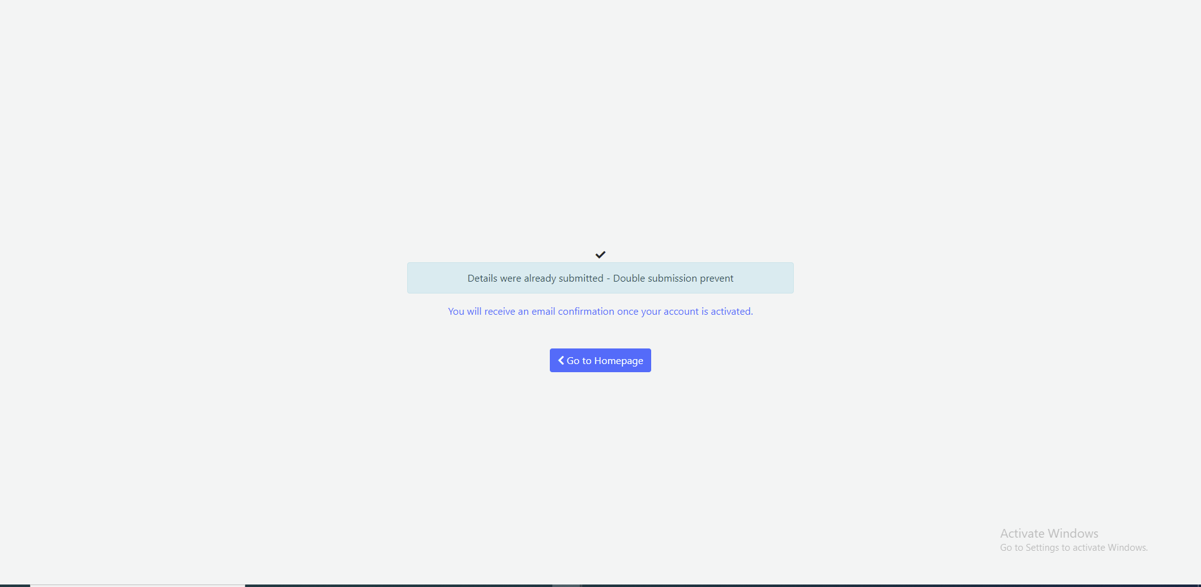

You will be required to keep checking your email account to find out whether your registration request was approved so that you can proceed to login. Usually, it takes 1 business day.

SIGN IN

Steps of sign in:
1. Go to the login page, enter your email and then click sign in.
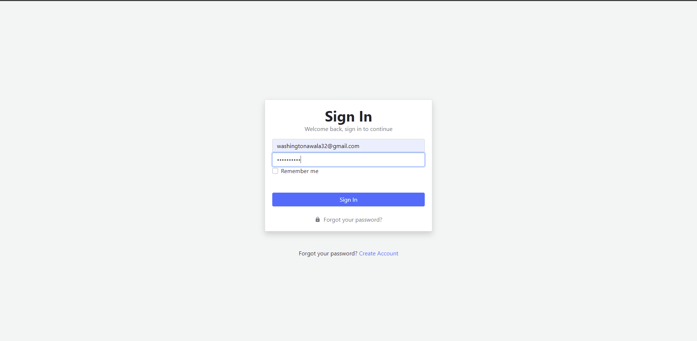

On a successful login, you’ll be redirected to the dashboard page.
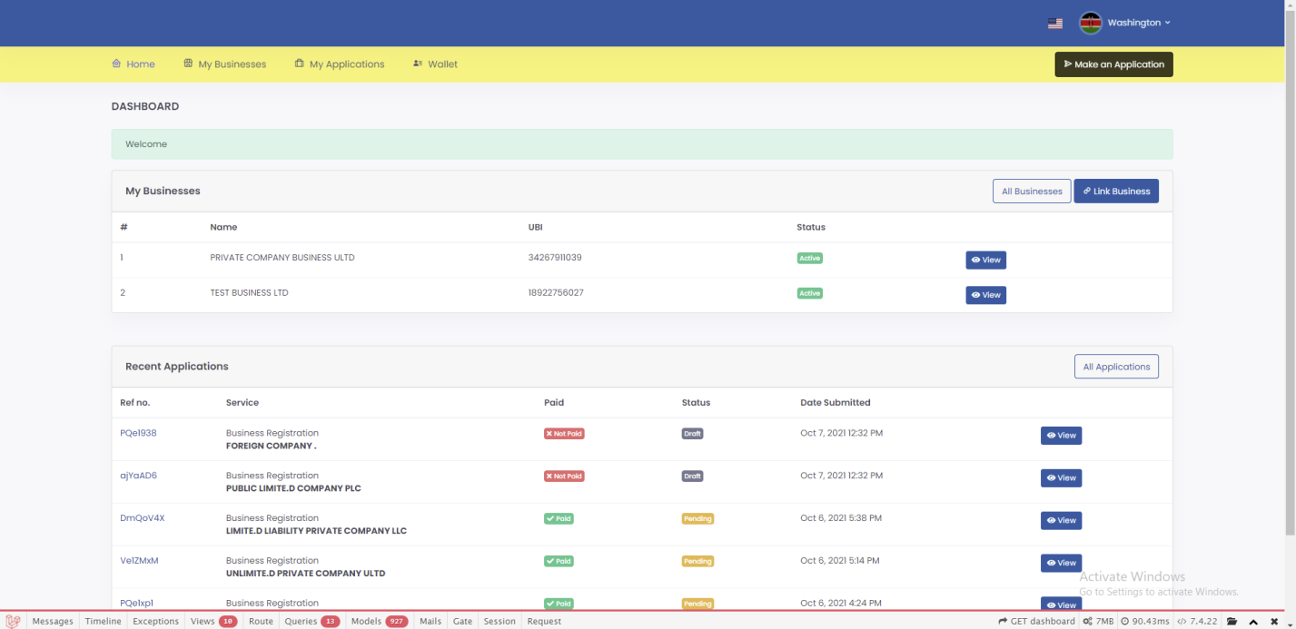

RESET PASSWORD

Steps of password reset:
1. In the login page, click forgot password.
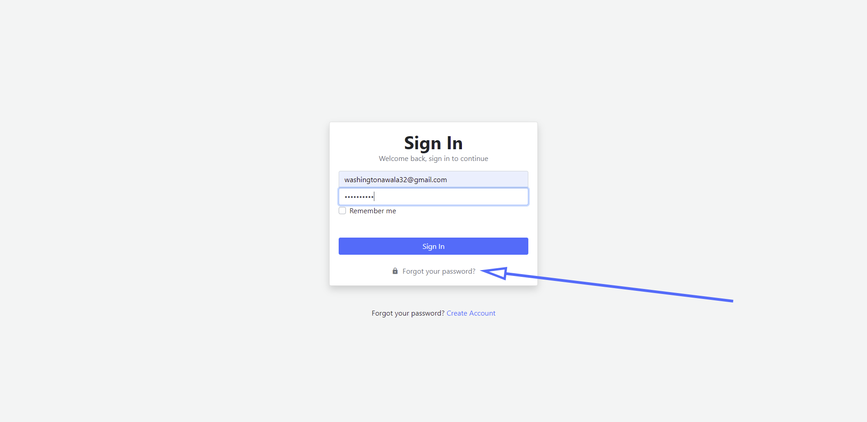

2. Enter your email address then click continue.
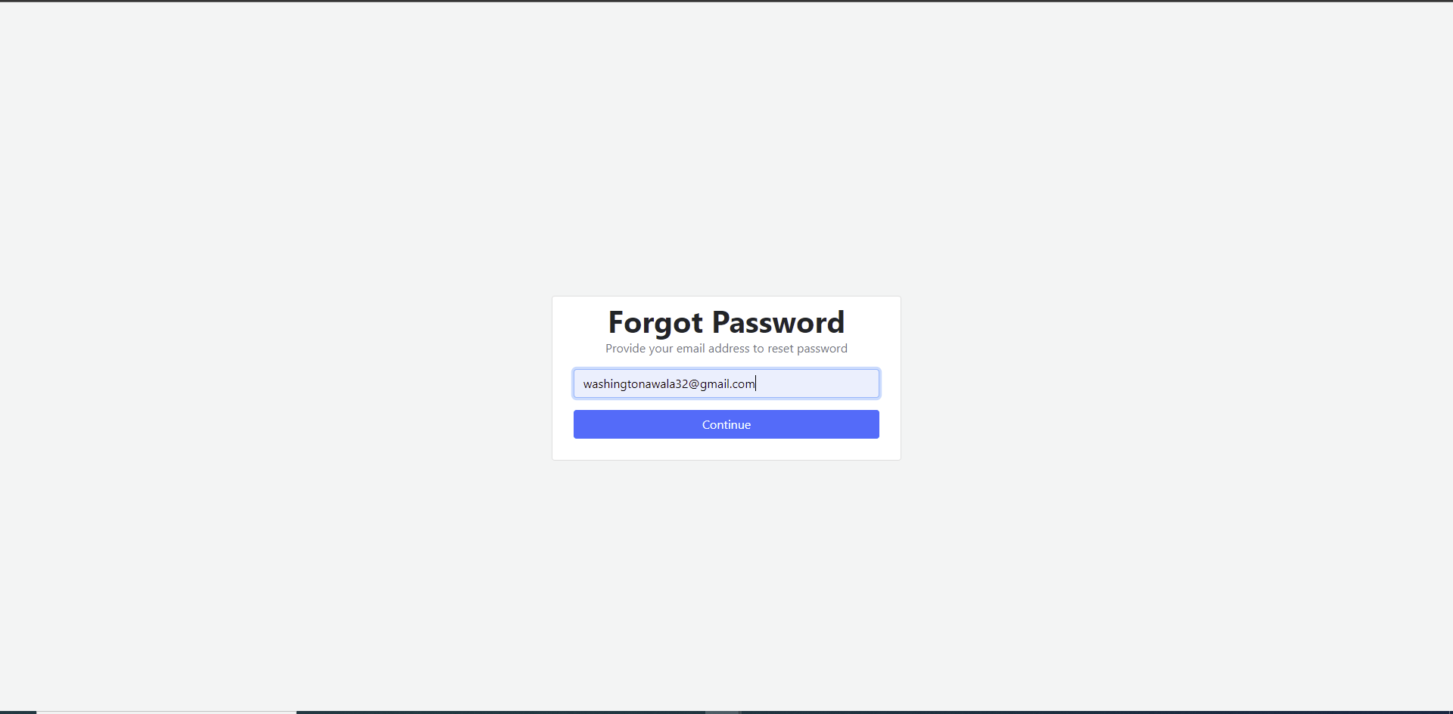

3. Click the password reset link sent to your email. On the password reset page, enter new password and password confirmation then click continue.
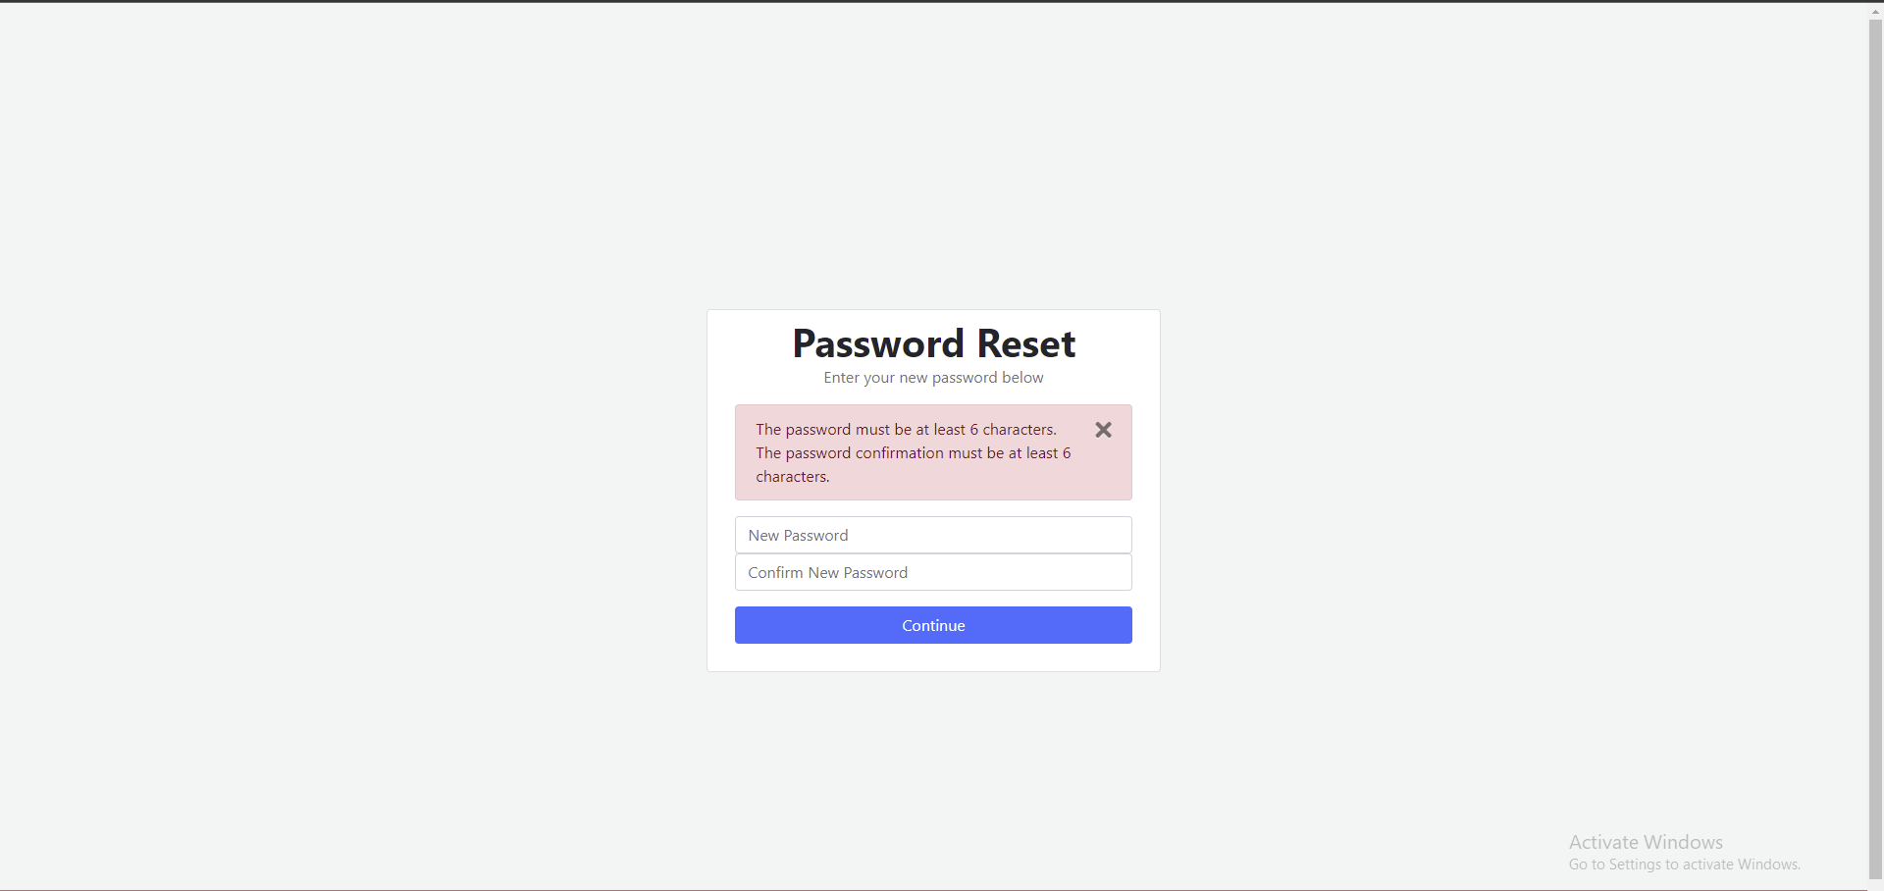

On a successful password reset, you’ll be redirected to the login page with a success message.
