APPLICATION FOR COPY OF RECORDS

AUTHOR WASHINGTON AWALA

Purpose
The purpose of this document is to provide a visual guide on how to apply for business copy of records.
Prerequisites
Individual submitting a request must have an SBRL account.
The business whose copy of records is being requested must be registered.

Steps of application for copy of records:
1. On the dashboard click make application button at the top right.
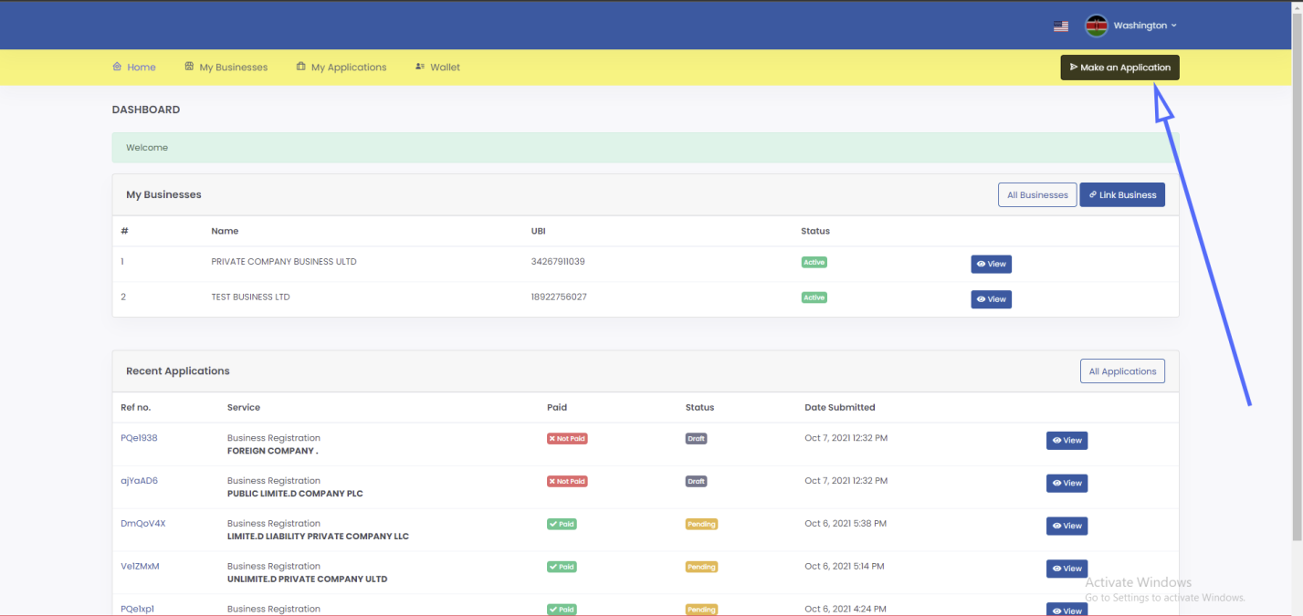

2. Click on proceed on the Application of Copy of Records.
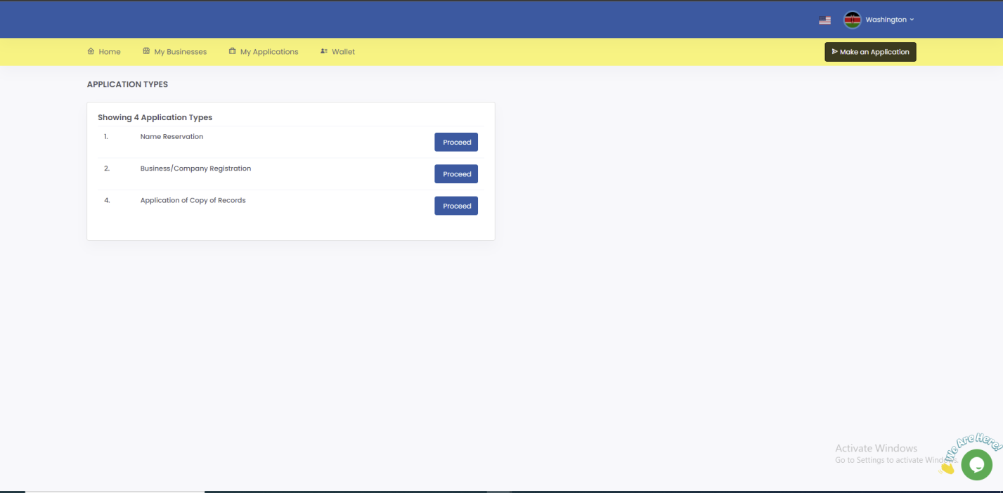

3. In Step 1(Select business) search for business using UBI number, select the business then click save and continue.
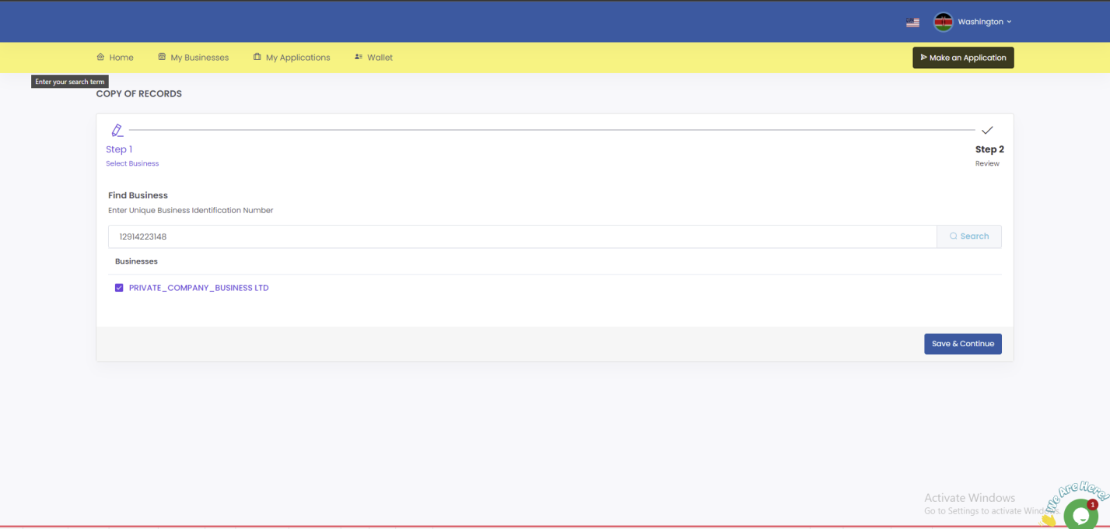

4. In Step 2 (Review) review the application then click submit.
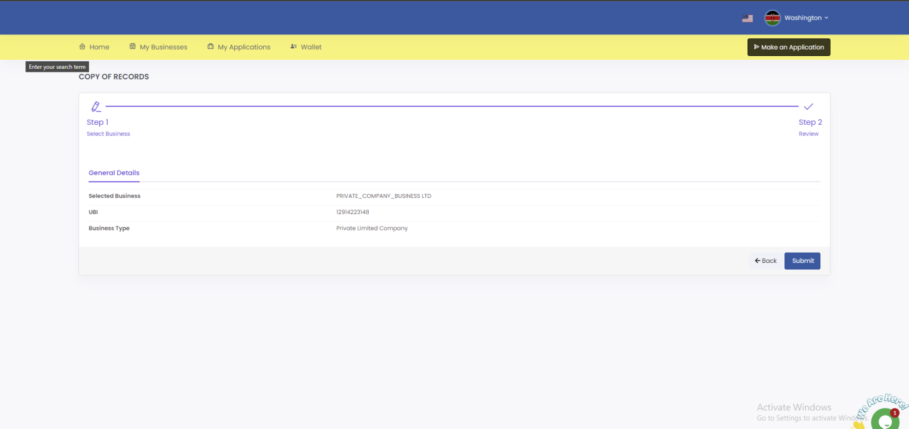

5. You’ll be redirected to the summary of the application page, scroll down then click download.
