MANAGE BUSINESS

AUTHOR WASHINGTON AWALA

Purpose
The purpose of this document is to provide a visual guide on how add business activities and acquire the business license.
Prerequisites
Individual submitting a request must have an SBRL account.
The individual submitting a request must have a registered business.

Steps of adding business activities:
1. On the dashboard navigation bar click my businesses.
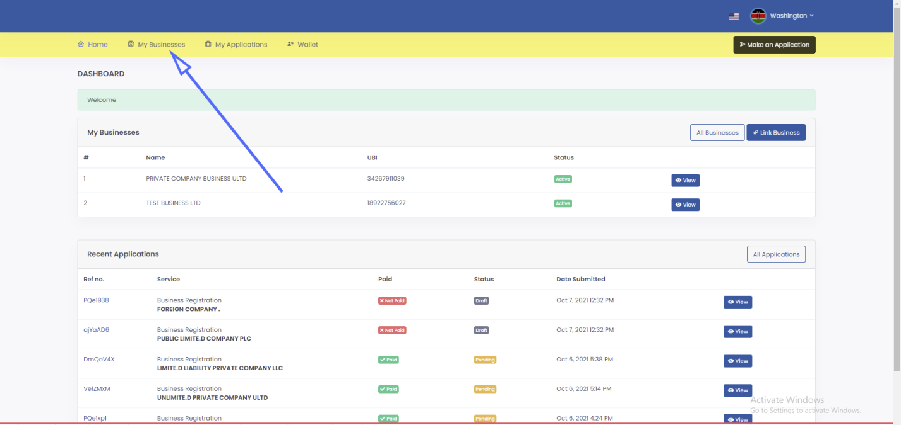

2. Click view button at the right side of the respective business.
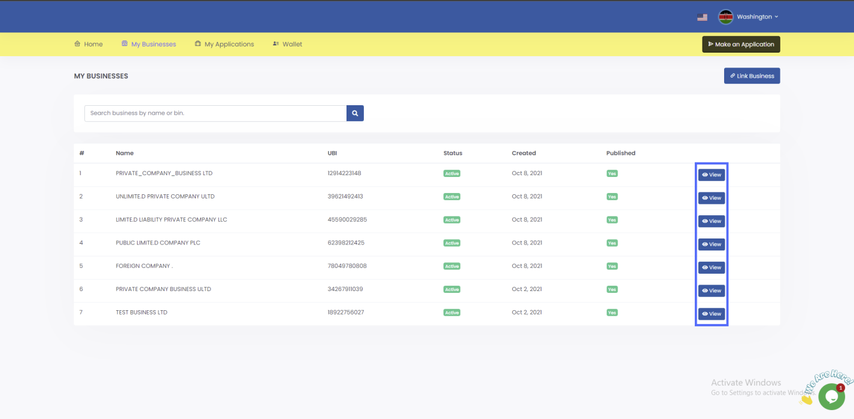

3. Click manage button in the business page.
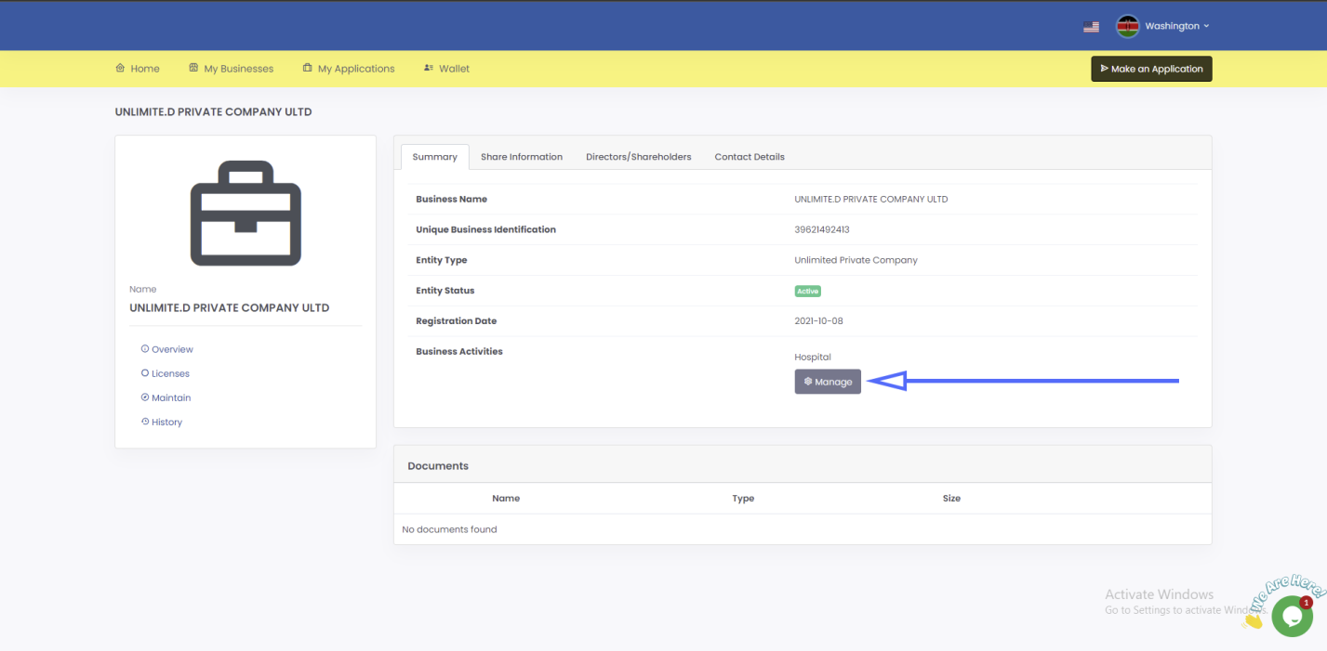

4. On the modal that pops up, click add activity, select the activity to be added then click submit.
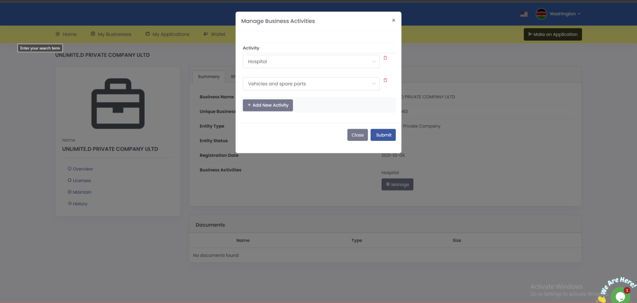

5. Select the activity select type of license whether renewal or new and then click get license to apply for license.
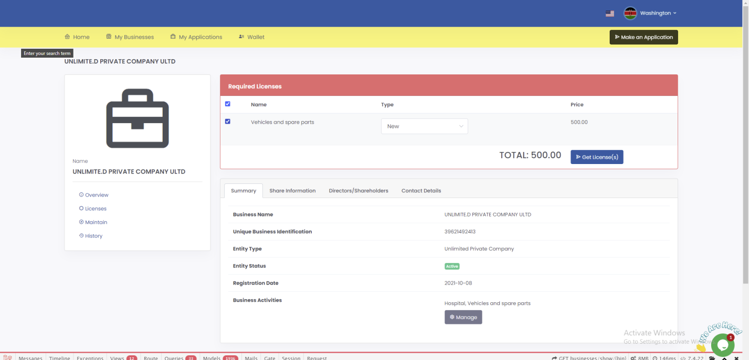

6. An invoice will be generated for the notice of change of name. Click on Pay from wallet to pay the requested amount. If you don’t have any knowledge of how to top up your wallet please follow the how to top up wallet user guide.
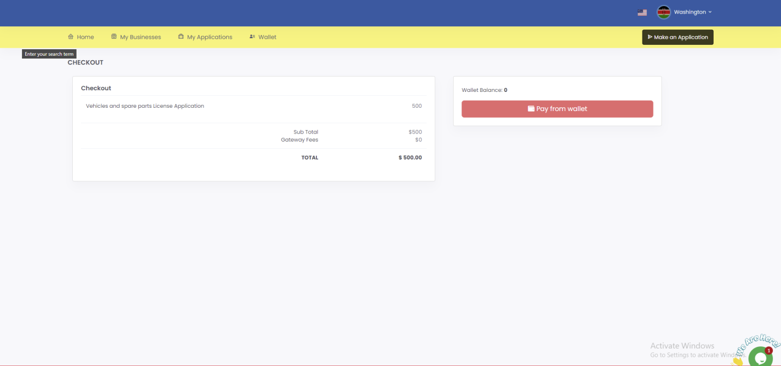

7. Once payment is successful you will be see the page below.
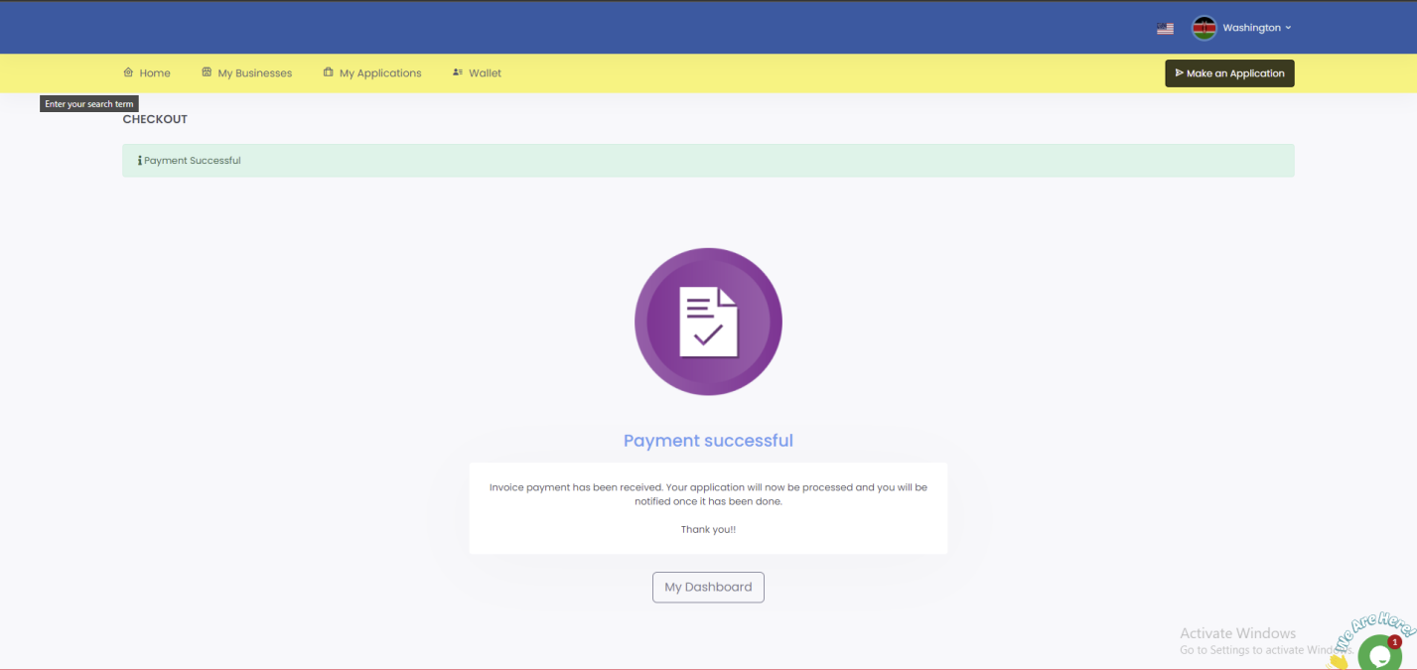

You will be required to keep checking your SBRL account to find out whether your application has been approved. Usually, it takes 1 business day.

