MAINTAIN BUSINESS

AUTHOR WASHINGTON AWALA

NOTICE OF CHANGE OF BUSINESS ADDRESS

Purpose
The purpose of this document is to provide a visual guide on how to apply for change of business address.
Prerequisites
Individual submitting a request must have an SBRL account.
The individual submitting a request must have a registered business.

Steps of application for change of business address:
1. On the dashboard navigation bar click my businesses.
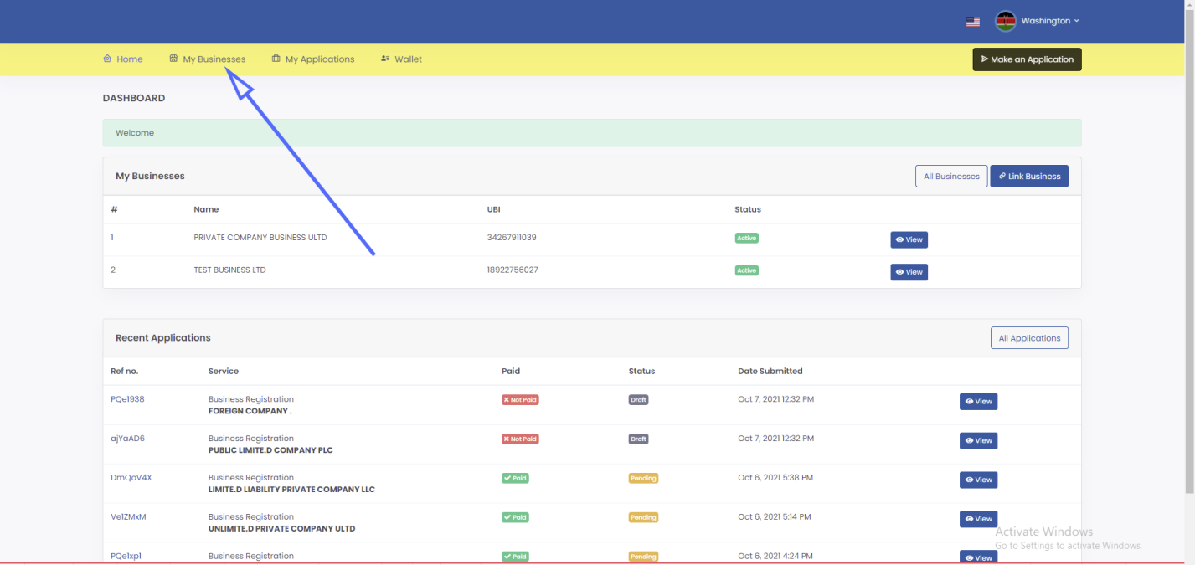

2. Click view button at the right side of the respective business.
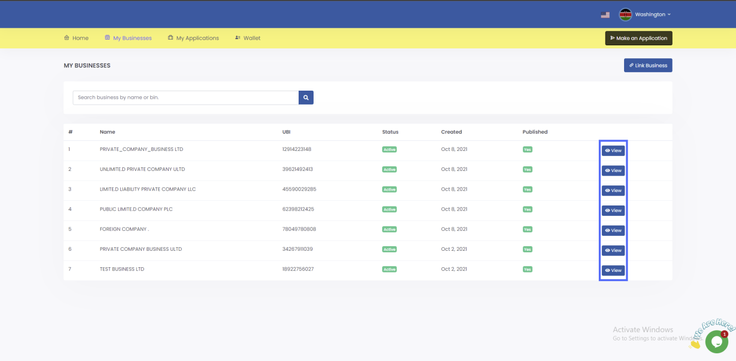

3. Click maintain button in the business page.
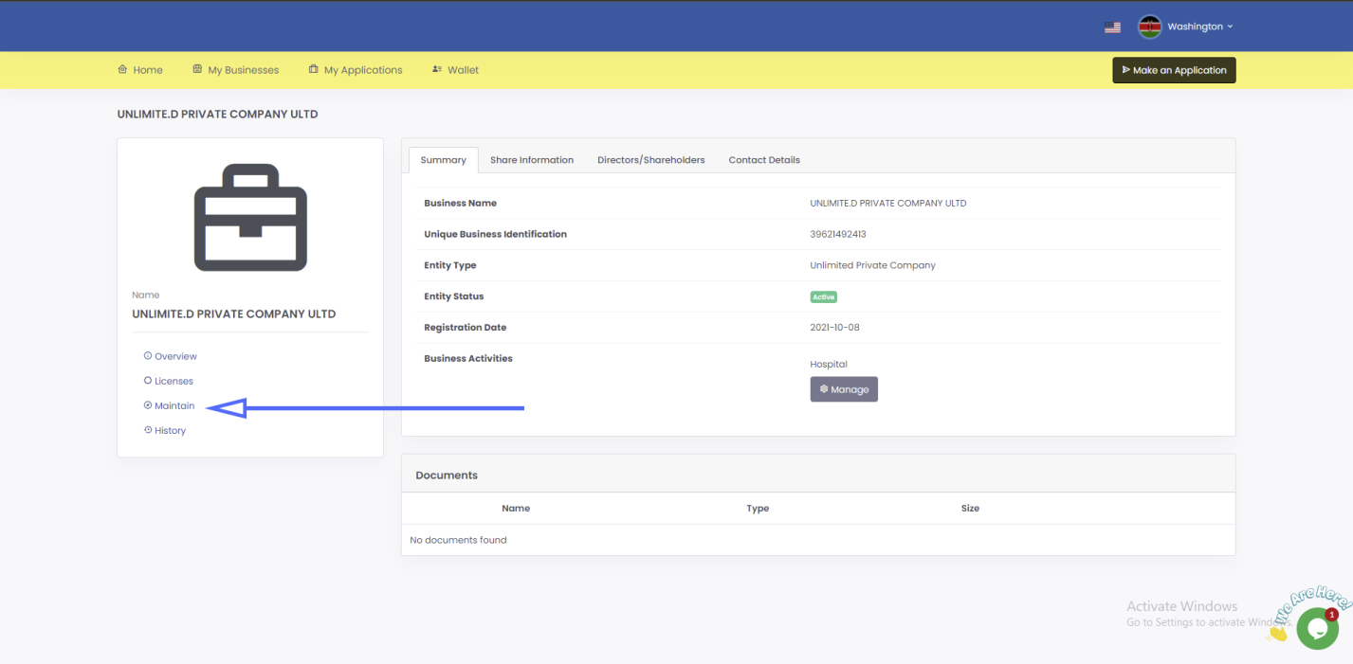

4. On the notice of change of location of company registered office click apply.
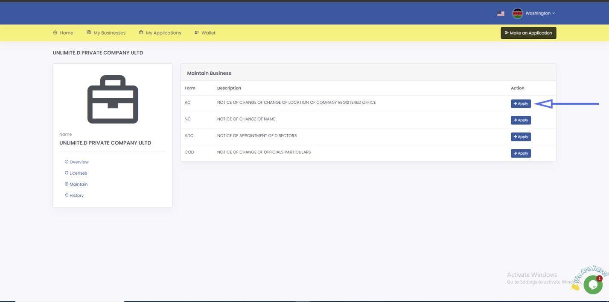

5. Click add address and fill out the address form, click submit then click save and continue.
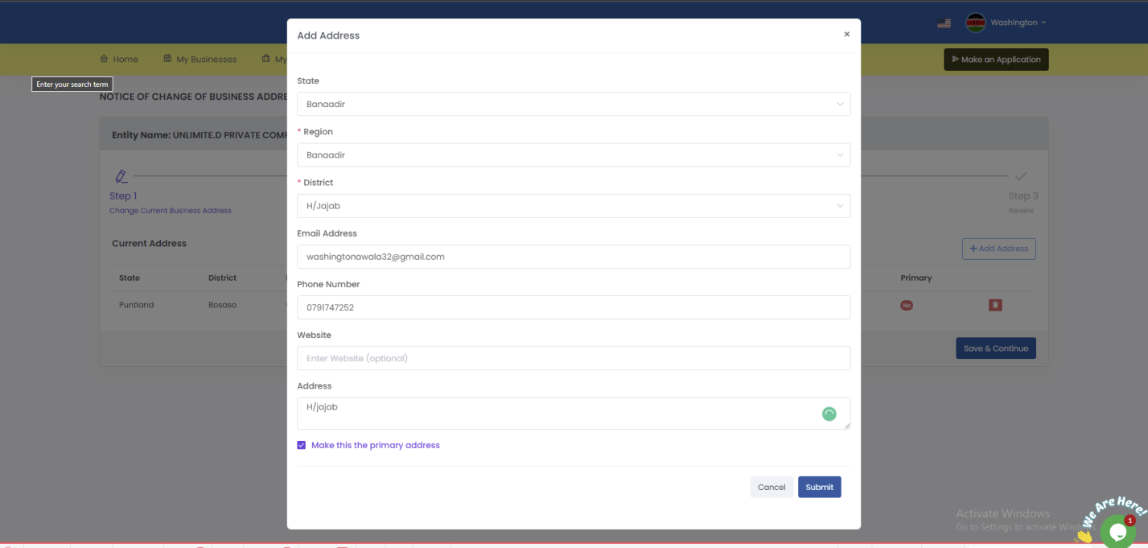
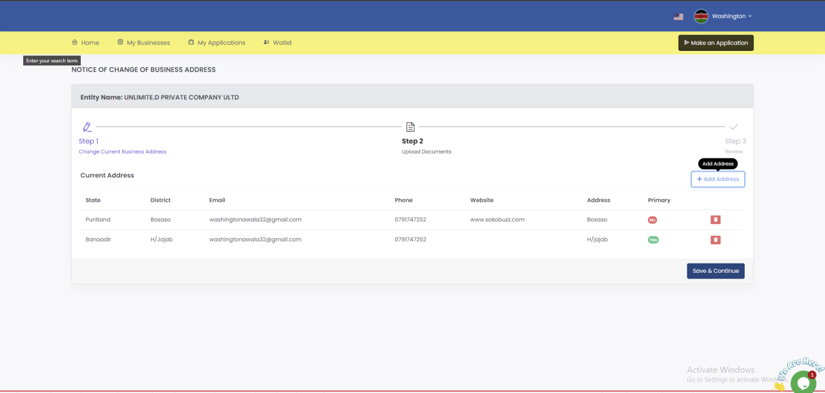

6. Upload notice of change of change of location of company registered office, upload notary then click save and continue.
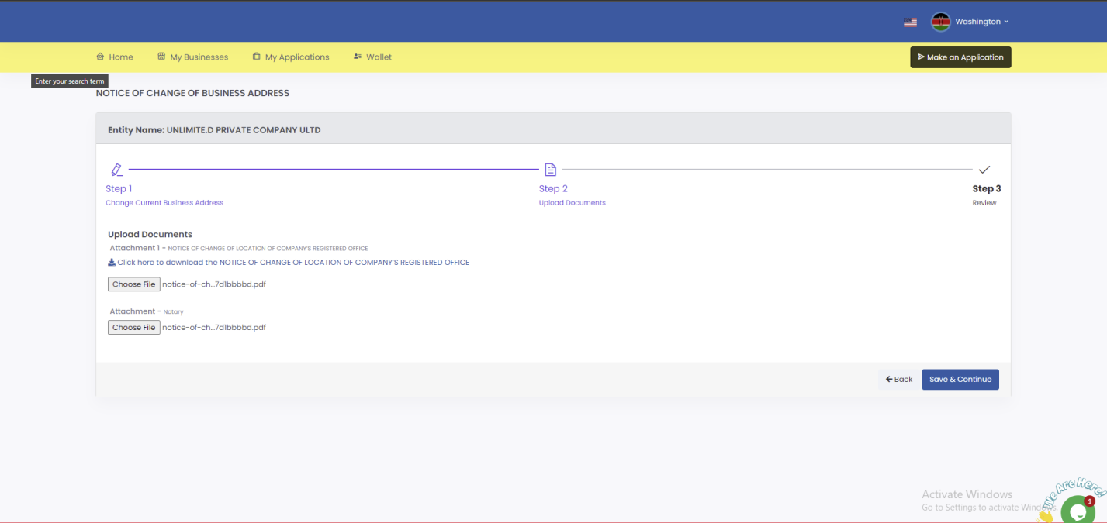

7. Review the information; confirm that you have provided all the required documents then click submit.
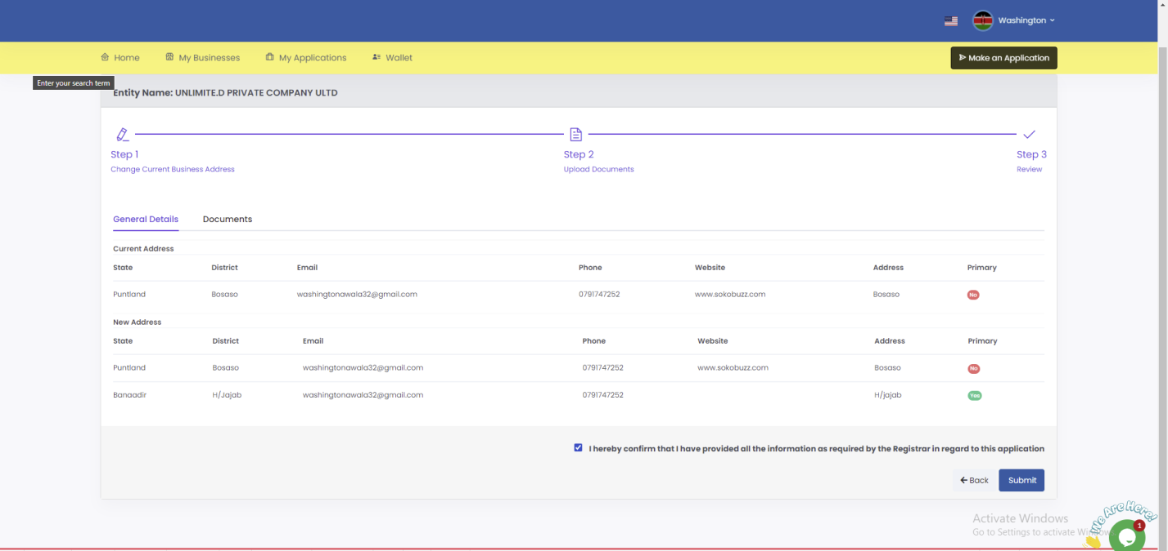

8. Once application is successful you will be redirected to application summary page with a success message.
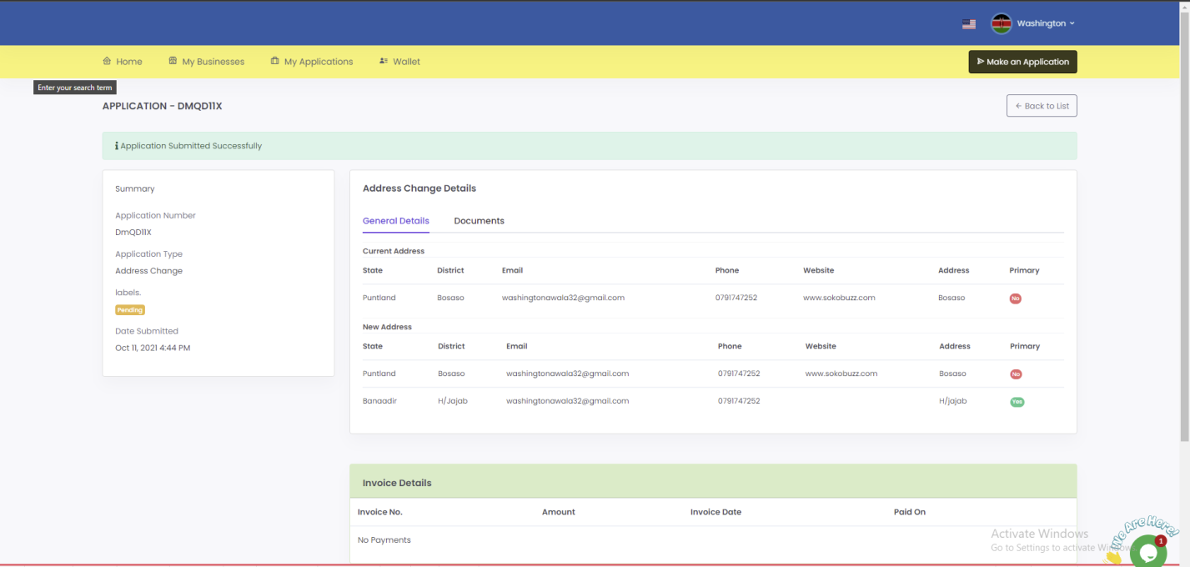

You will be required to keep checking your SBRL account to find out whether your application has been approved. Usually, it takes 1 business day.

NOTICE OF CHANGE OF NAME

Purpose
The purpose of this document is to provide a visual guide on how to apply for change of business name.
Prerequisites
Individual submitting a request must have an SBRL account.
The individual submitting a request must have a registered business.
The business name that the business is changing to must be reserved.

Steps of application for change of business name:
1. On the dashboard navigation bar click my businesses.

2. Click view button at the right side of the respective business.

3. Click maintain button in the business page.

4. On the notice of change of name click apply.
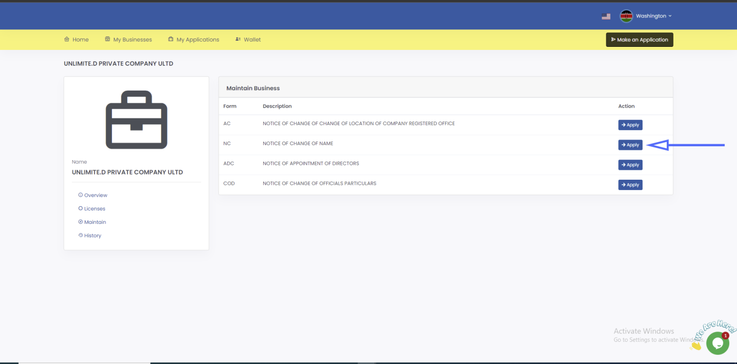

5. Select the business name.
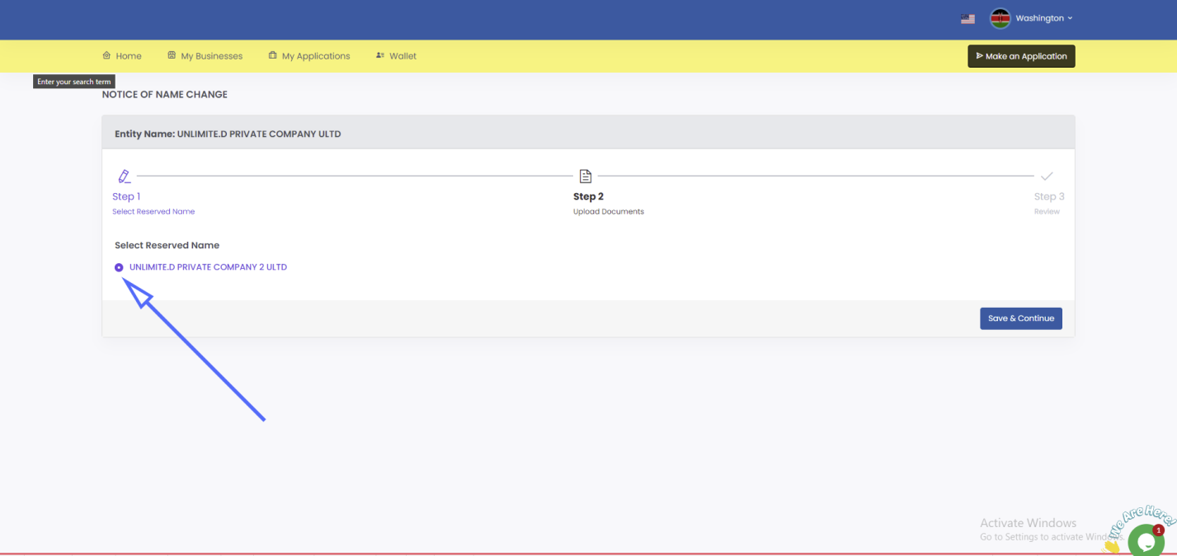

6. Download notice of change of name document and download notice of special/ordinary resolution for notice of change of address document. These two documents must be signed and stamped then upload them alongside notary then click save and continue.
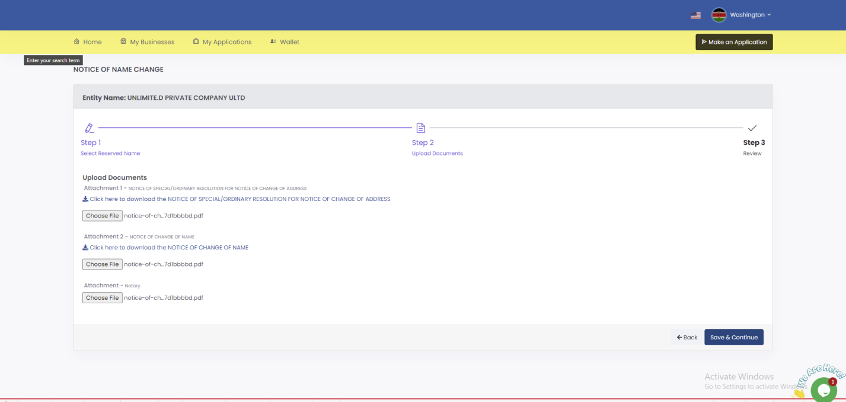

7. Review the information; confirm that you have provided all the required documents then click submit.
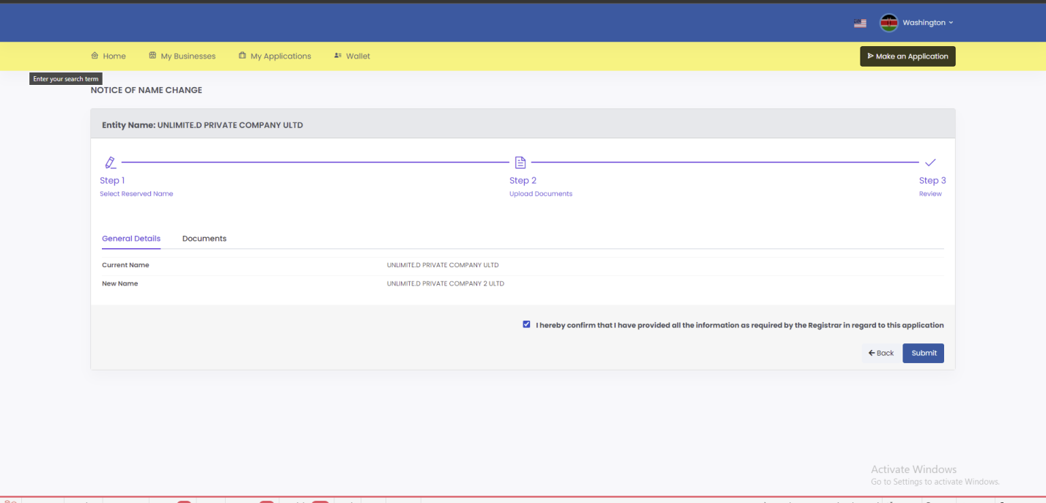

8. An invoice will be generated for the notice of change of name. Click on Pay from wallet to pay the requested amount. If you don’t have any knowledge of how to top up your wallet please follow the how to top up wallet user guide.
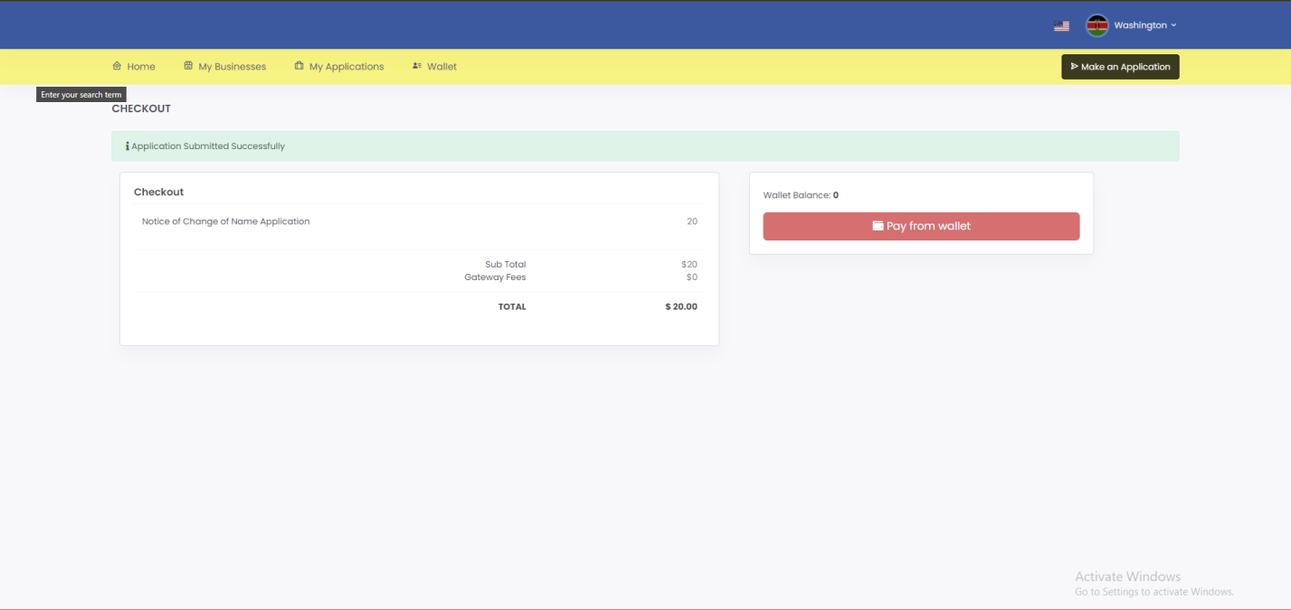

9. Once payment is successful you will be see the page below.
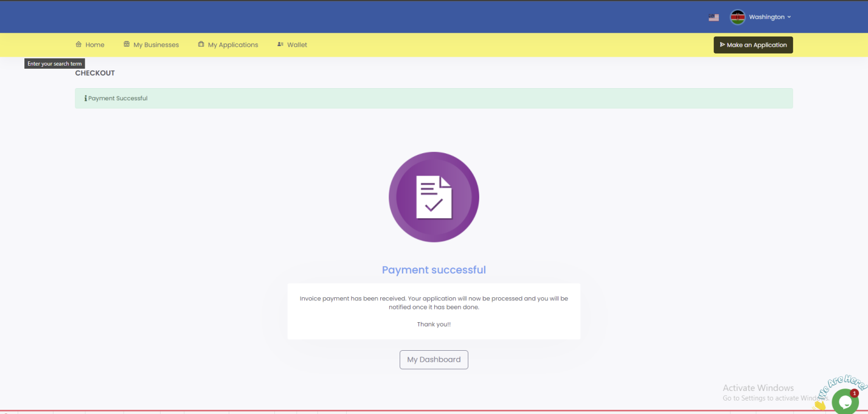

You will be required to keep checking your SBRL account to find out whether your application has been approved. Usually, it takes 1 business day.

NOTICE OF APPOINTMENT OF DIRECTORS

Purpose
The purpose of this document is to provide a visual guide on how to apply for appointment of directors.
Prerequisites
Individual submitting a request must have an SBRL account.
The individual submitting a request must have a registered business.

Steps of application for appointment of directors:
1. On the dashboard navigation bar click my businesses.

2. Click view button at the right side of the respective business.

3. Click maintain button in the business page.

4. On the notice of appointment of directors click apply.
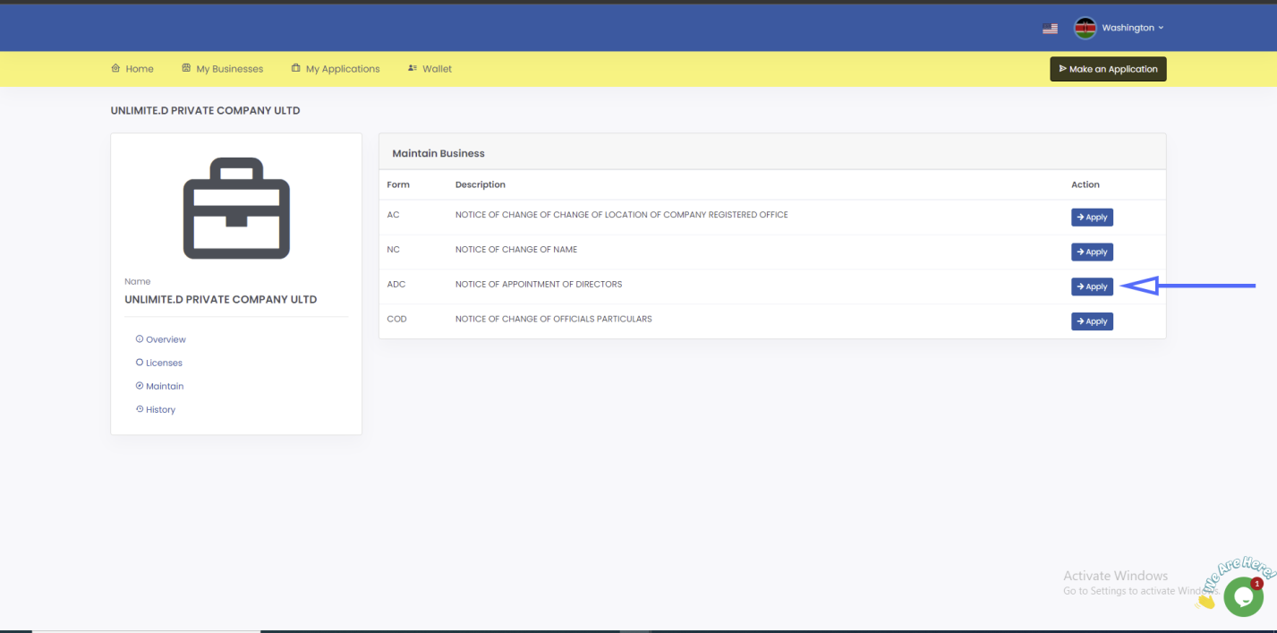

5. Click add director. On the modal that pops up search for the director, select a role for the added director click submit
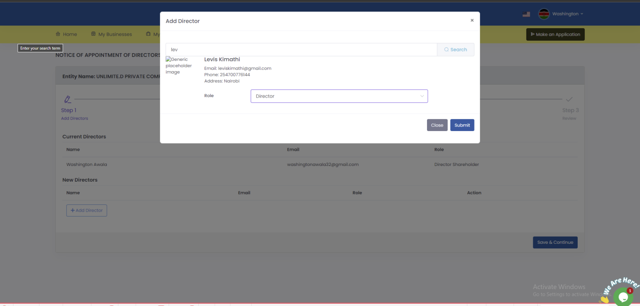

6. Click save and continue
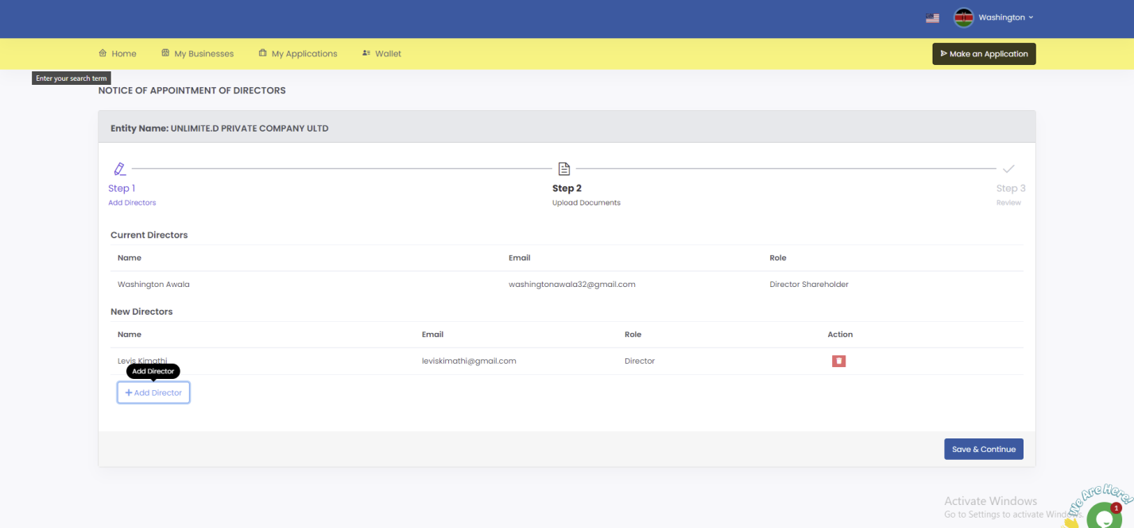

7. Download notice of change of appointment of director document and download notice of special/ordinary resolution for notice of change of address document. These two documents must be signed and stamped then upload them alongside notary then click save and continue.
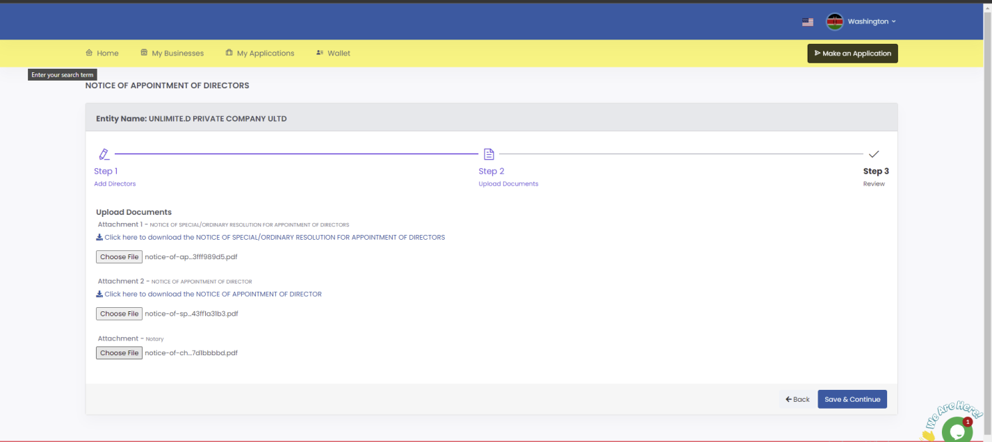

8. Review the information; confirm that you have provided all the required documents then click submit.
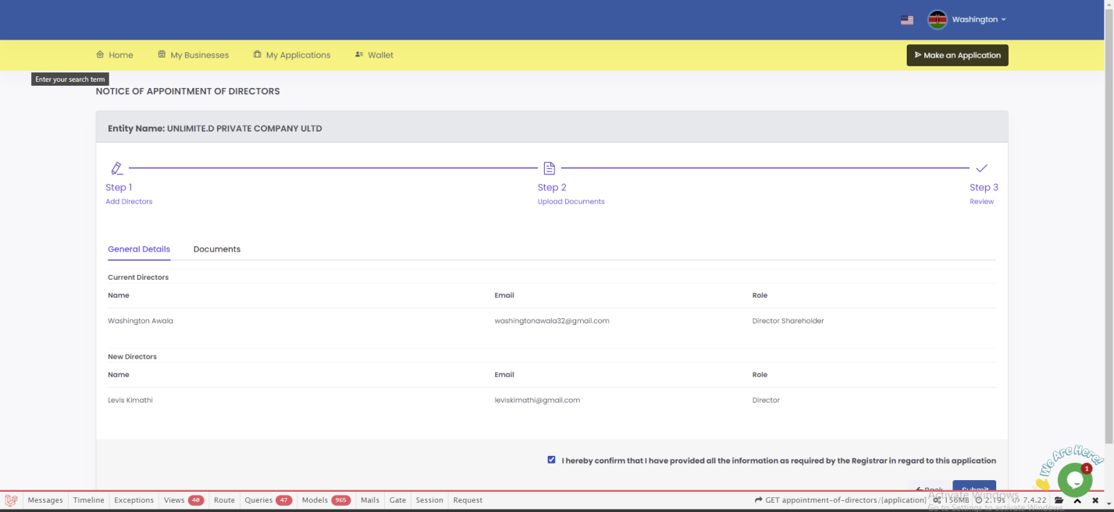

9. Once application is successful you will be redirected to application summary page with a success message.
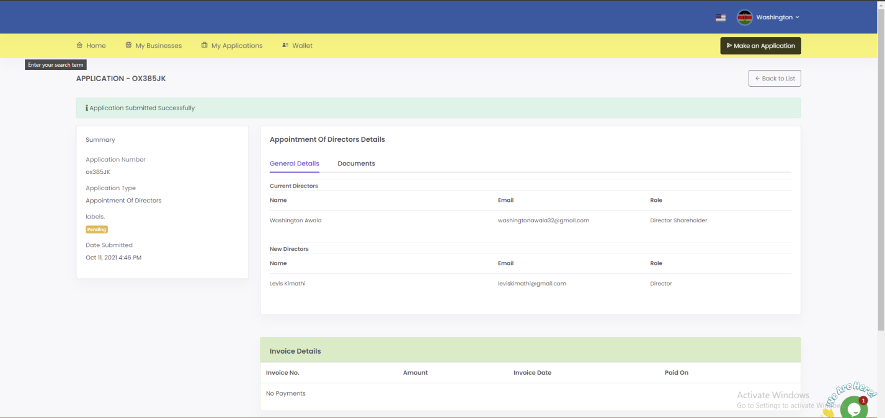
You will be required to keep checking your SBRL account to find out whether your application has been approved. Usually, it takes 1 business day.

NOTICE OF CHANGE OF OFFICIALS PARTICULARS
Purpose
The purpose of this document is to provide a visual guide on how to apply for notice of change of officials particulars.
Prerequisites
Individual submitting a request must have an SBRL account.
The individual submitting a request must have a registered business.

Steps of application for change of official particulars:
1. On the dashboard navigation bar click my businesses.

2. Click view button at the right side of the respective business.

3. Click maintain button in the business page.

4. On the notice of change of official particulars click apply.
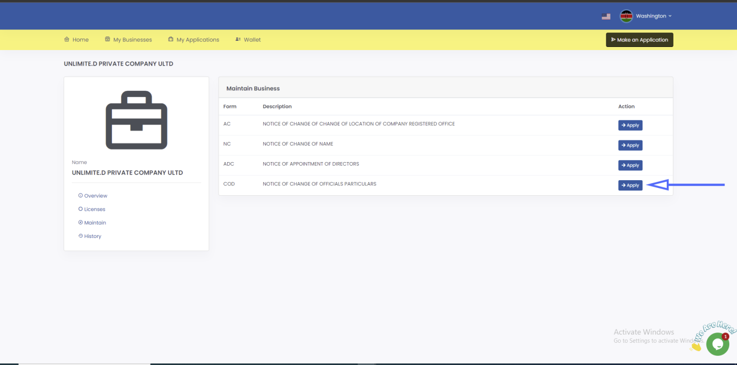

5. Step 1(Share Information) - Click add new category. Select share type, enter number of shares, enter nominal value then click save and continue.
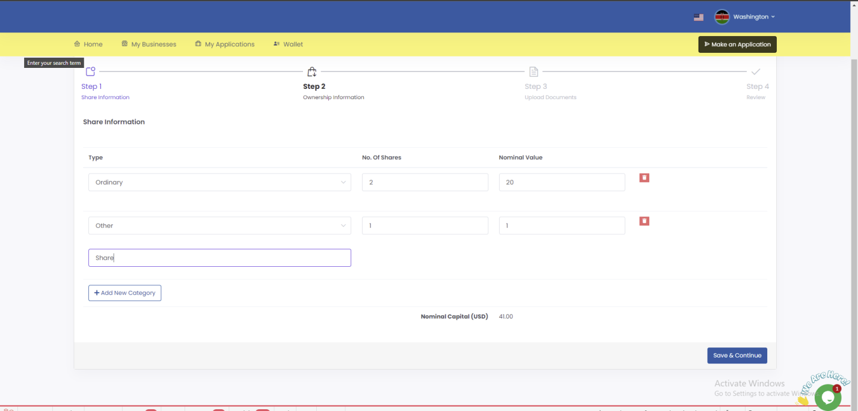

6. Step 2(Ownership Information) - Click add new official. On the modal that pops up select individual type, search for individual using email address or the business using UBI number, in this case we search for an individual. Select role, allocate shares then click submit.
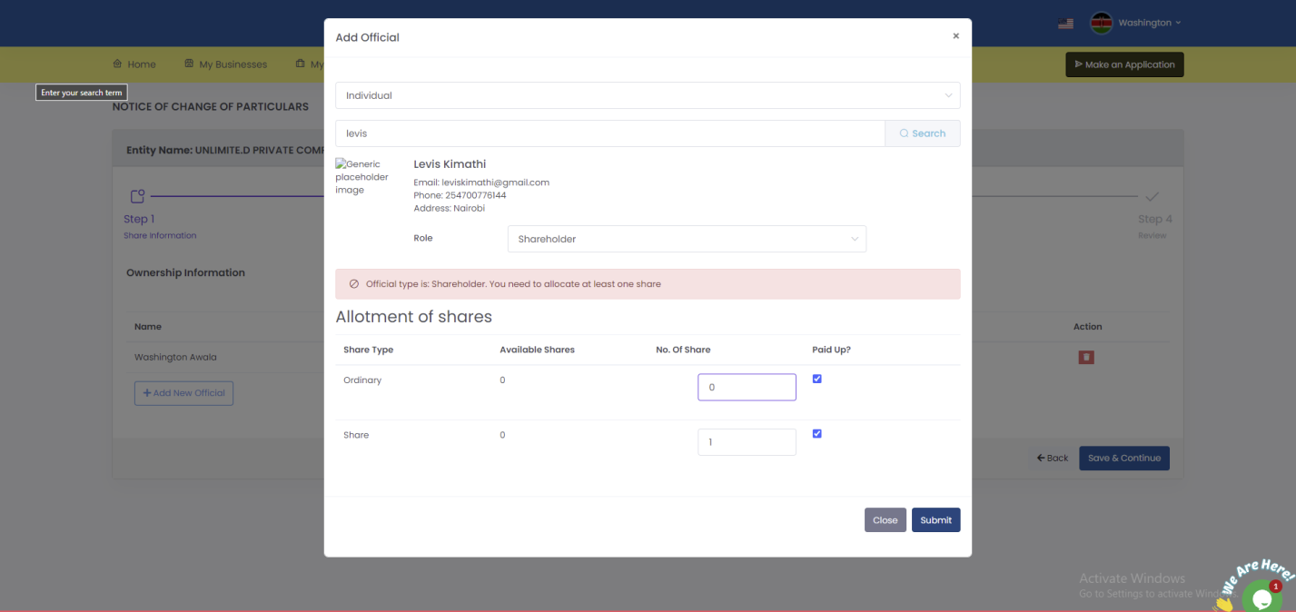

7. Click save and continue
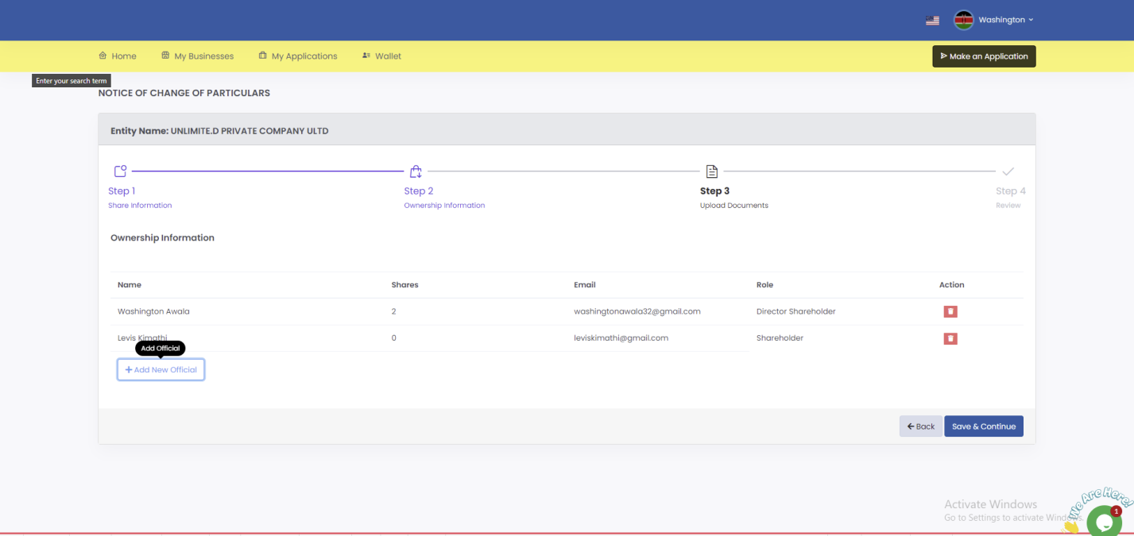

8. Upload notary document then click save and continue.
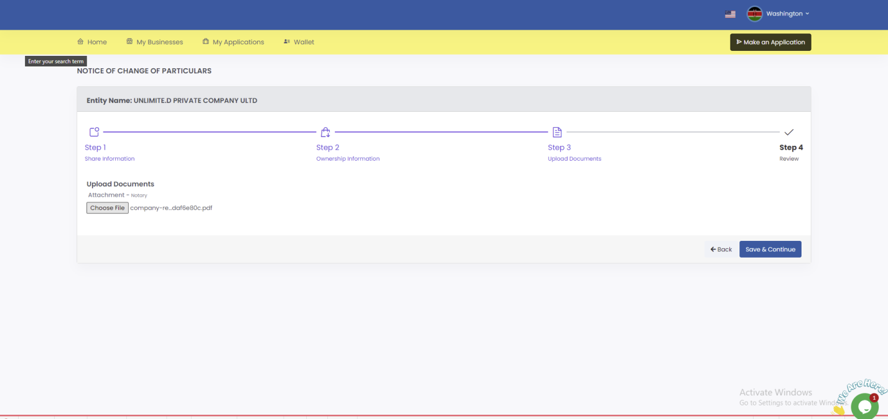

9. Review the information; confirm that you have provided all the required documents then click submit.
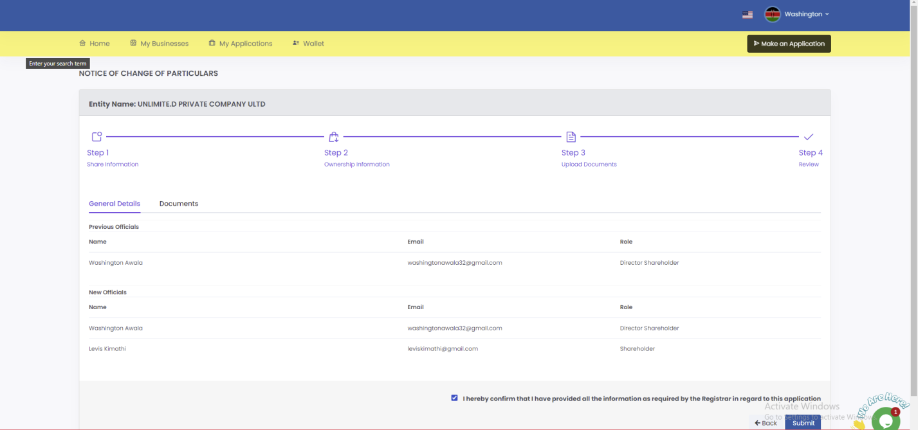

10. Once application is successful you will be redirected to application summary page with a success message.
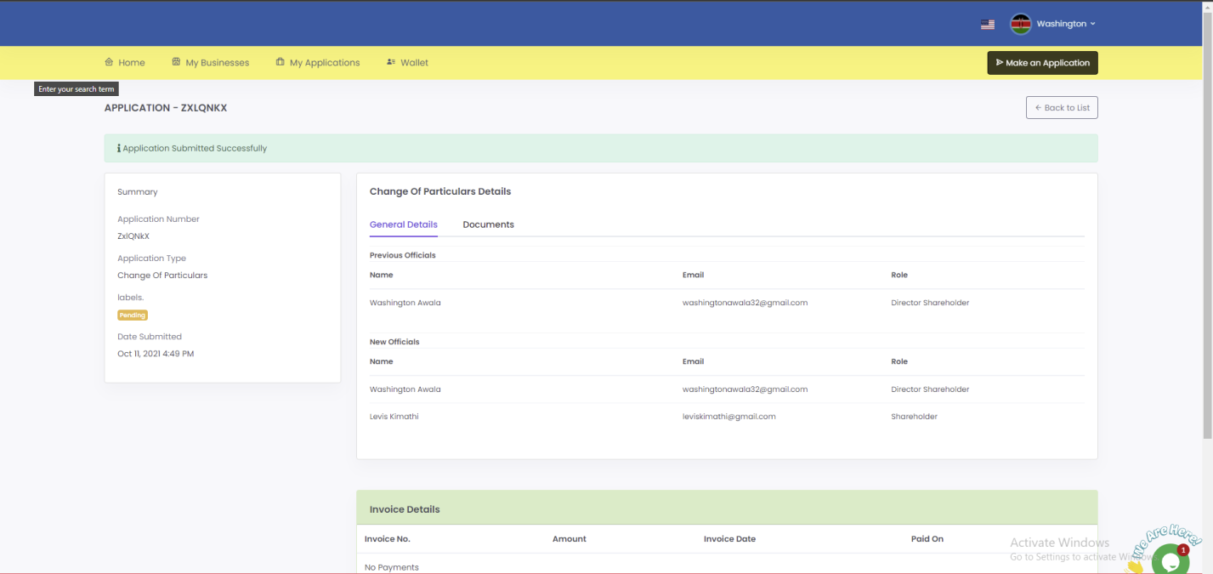

You will be required to keep checking your SBRL account to find out whether your application has been approved. Usually, it takes 1 business day.

