BUSINESS NAME SEARCH AND RESERVATION USER MANUAL

AUTHOR LEVIS KIMATHI KARWIRWA

Purpose
The purpose of this document is to provide a visual guide on how to submit a request/application for business name search.
Prerequisites
Individual submitting a request must have an SBRL account.
The Business Name is the simplest business form under which one can operate a business. The Business Name is not a legal entity. It simply refers to a person who owns the business and is personally responsible for its debts. The Company Registry under Attorney General requires all applicants to request for a business name here. Currently, it takes one (1) day for the business name search to be processed. Before you perform a name search it is important to note the following,
1. Business with the word "LIMITED" at the end cannot be used.
2. Offensive or abusive words are not allowed either. Offensive words in vernacular (mother tongue) are not allowed either.
3. Political names are not allowed.

Steps of application:
1. Log into your SBRL account (ebusiness.gov.so) as illustrated below fill in your credentials and click Sign In
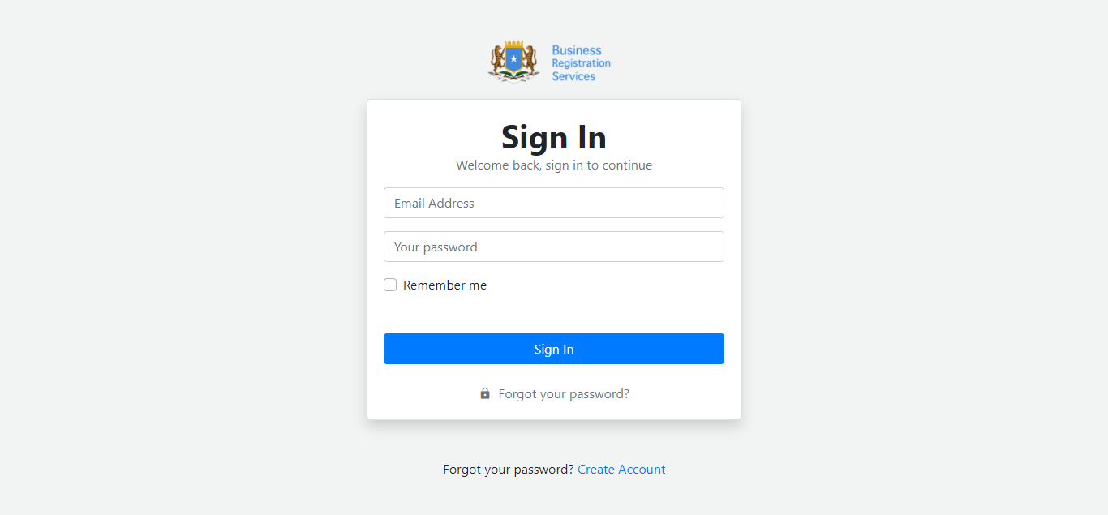

2. Click on Make an Application at the top right corner.
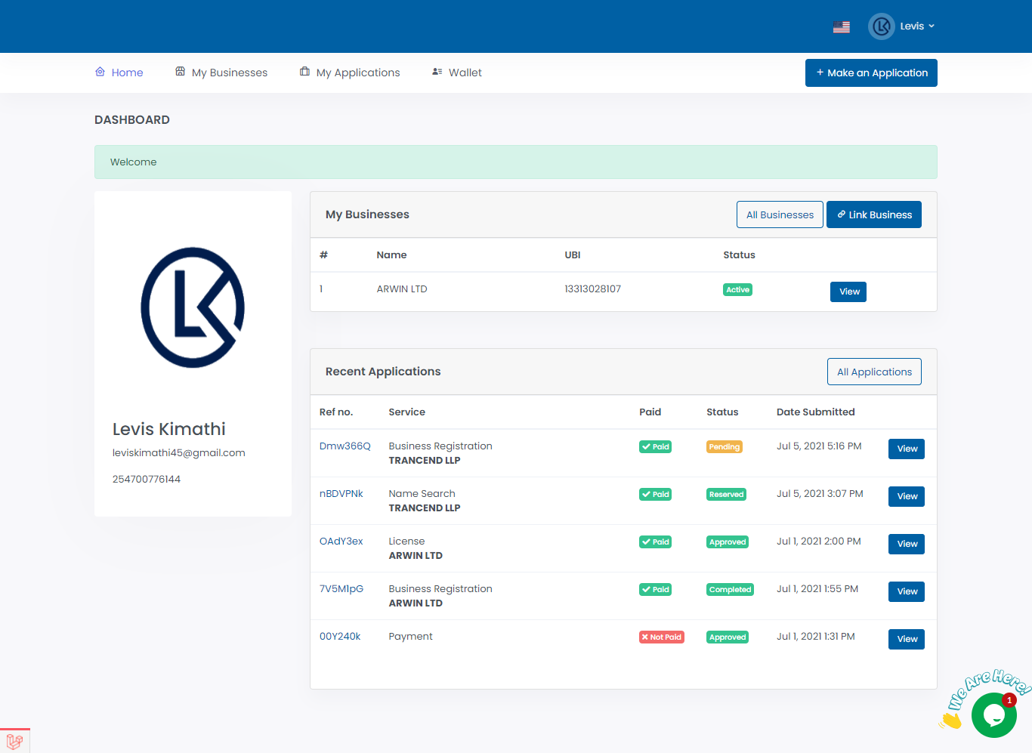

3. Click Proceed on the Name Reservation
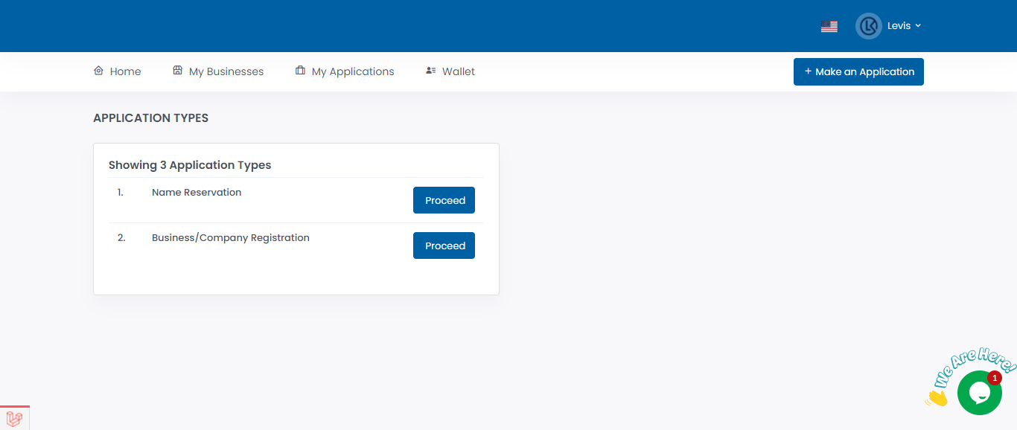

4. Use the top search pane to search and verify that your business name is available. If available proceed to choose entity type preferred business name and description. After filling the required information click Proceed. On the name search preview popup verify your details and Submit.

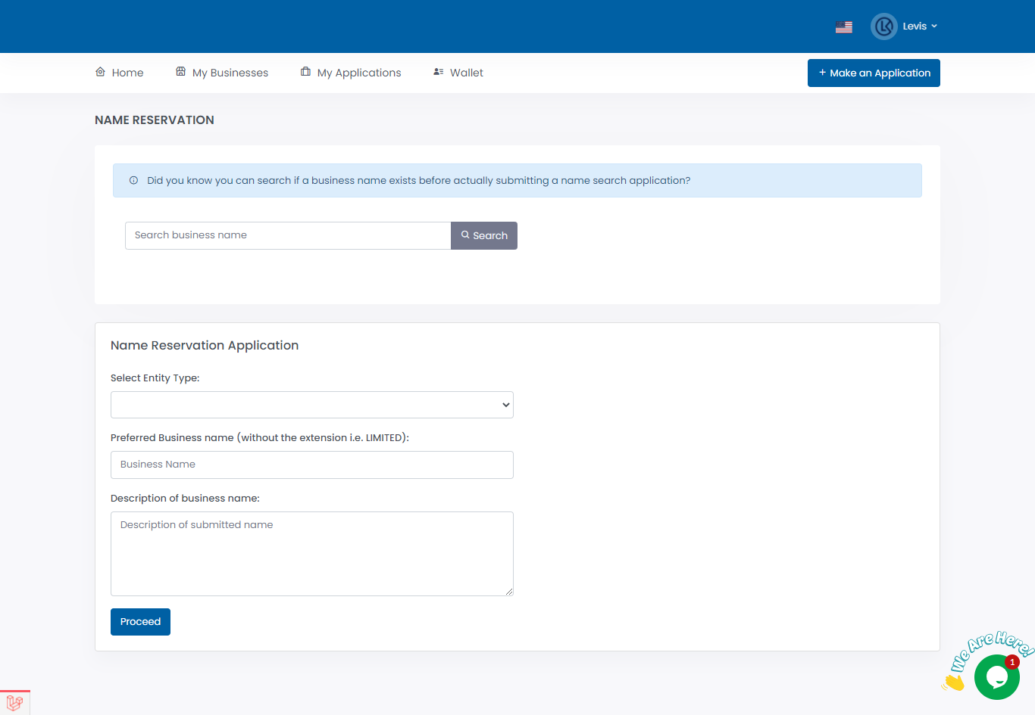

5. An invoice will be generated for the Name Reservation Application. Click on Pay from wallet to pay the requested amount. If you don’t have any knowledge of how to top up your wallet please follow the how to top up wallet user guide.
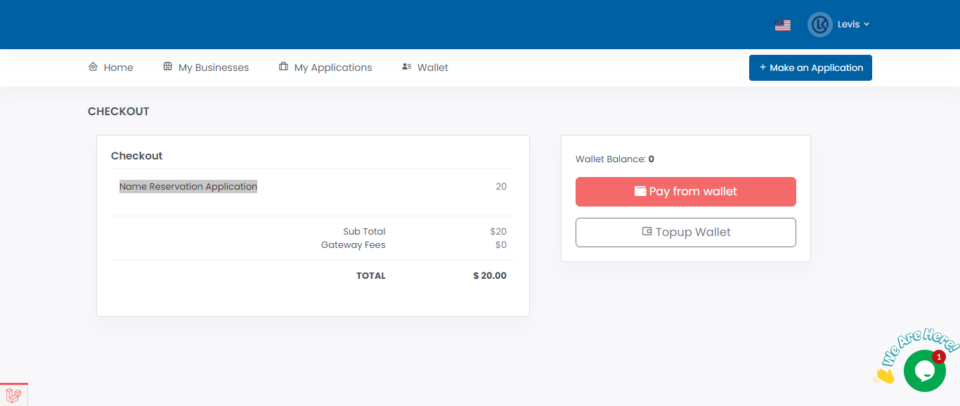

6 Once payment is successful you will see this page.
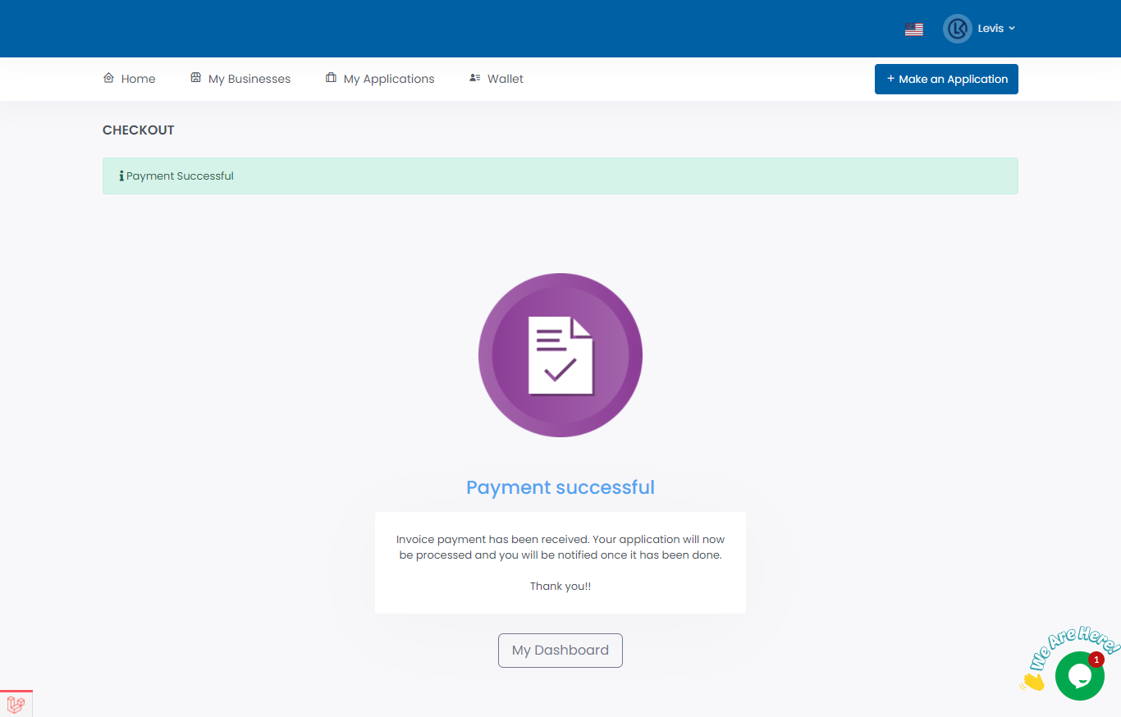

You will be required to keep checking your SBRL account to find out whether your preferred business name has been reserved or rejected. Usually, it takes 1 business day. It should be noted that there is no requirement for a minimum or maximum number of names that an application can give.

Circumstances in which a company name will not be registered
These circumstances are well illustrated under Section 10 of Companies (General) Regulations, 2015:
A company name may not be registered if:
1. it is the same as a name appearing in the Registrar’s Index of Company Names, Business Names, Limited Liability Partnerships or Partnerships;
2. it has a close phonetic resemblance to the name of company, business name, limited liability partnership or partnership that is already registered;
3. it differs from the name of another company, business name, limited liability partnership or partnership that is already registered only by the addition of the name of a place, locality or region within Kenya;
4. it is identical to, or closely resembles, that of a name that has been reserved by the Registrar for use in connection with a proposed company, business name, limited liability partnership or partnership;
5. it is identical to. or closely resembles, the name of a company or limited liability partnership that has been dissolved, or has been struck off the register of companies or register of limited liability partnerships, or the entry of a business in the register of business names or partnerships kept under the Registration of Business Names Act 2015 has been cancelled;
6. it is the same as a name of a body corporate or established under a written law;
7. the Registrar believes on reasonable grounds that its use would involve the commission of a criminal offence; or
8. the Registrar believes on reasonable grounds that it is offensive or undesirable or contrary to public interest.

