BUSINESS/COMPANY REGISTRATION

AUTHOR WASHINGTON AWALA

Purpose
The purpose of this document is to provide a visual guide on how to register business/company.
Prerequisites
Individual submitting a request must have an SBRL account.
A business name for the company being registered must have already been reserved.
The individual submitting the request must have money which will be used to pay fee charged for the business registration.

Steps of business registration:
1. On the dashboard click make application button at the top right.
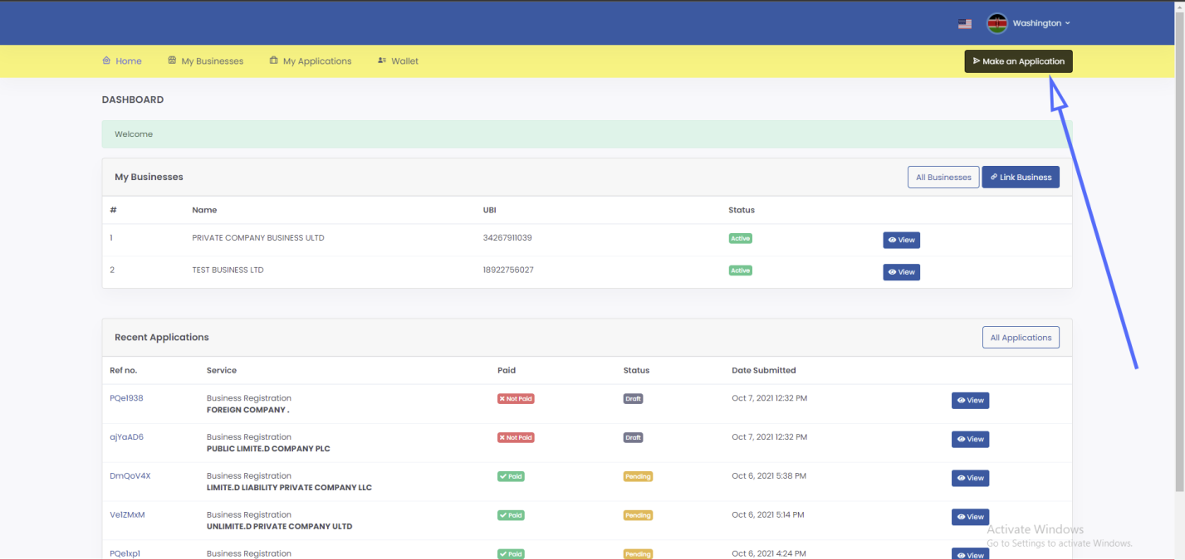

2. Click on proceed on the Business/Company Registration. You must have reserved a business name.
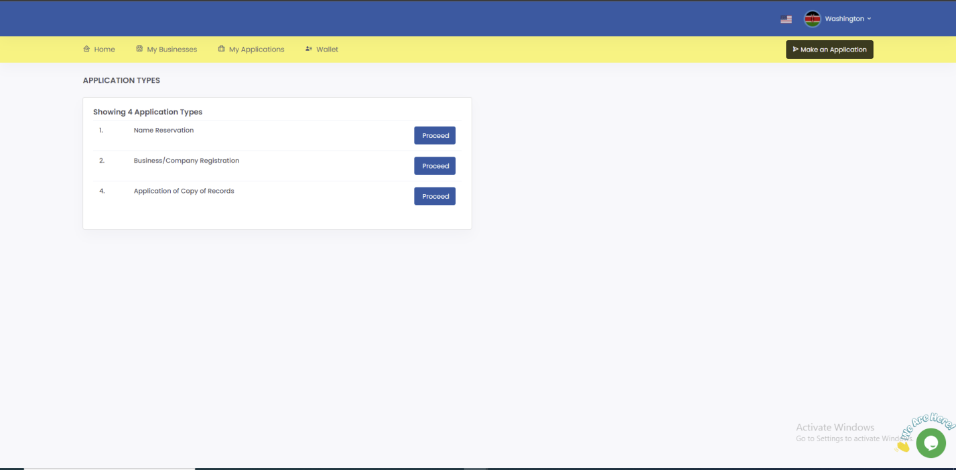

3. Click the register button on the reserved name.
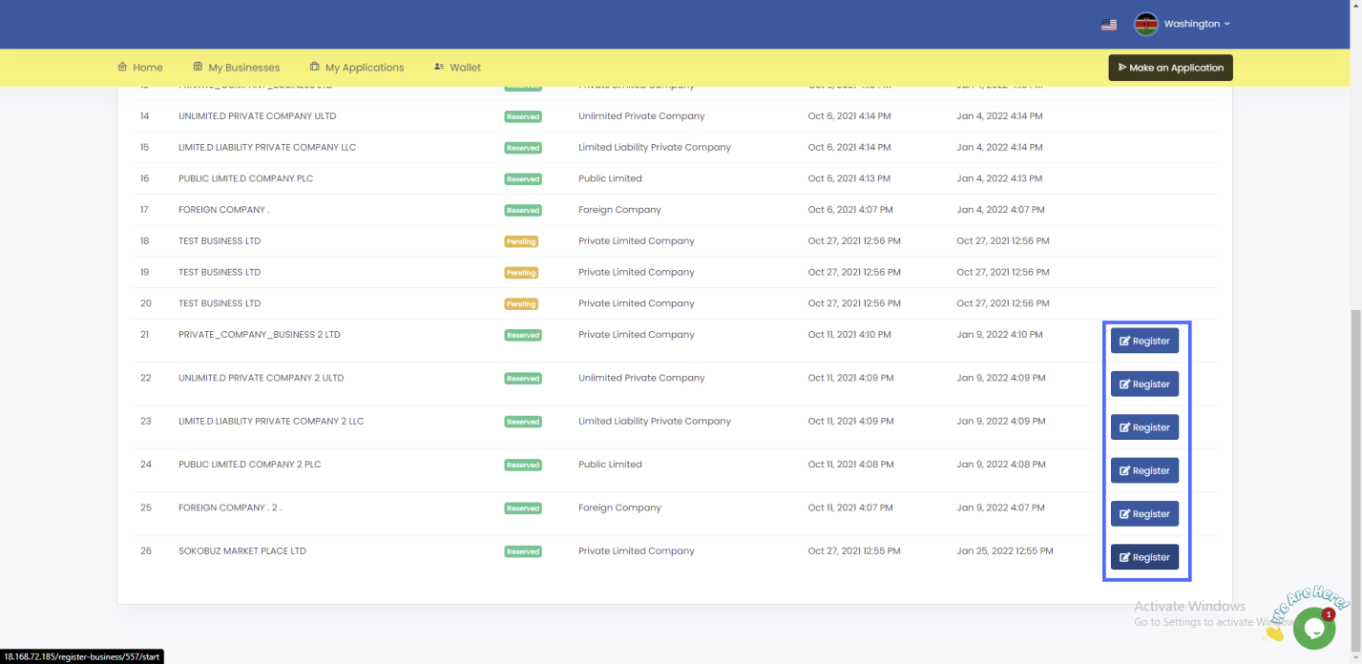

4. In Step 1(Articles and Memorandum) fill the form (fields marked with * are mandatory)
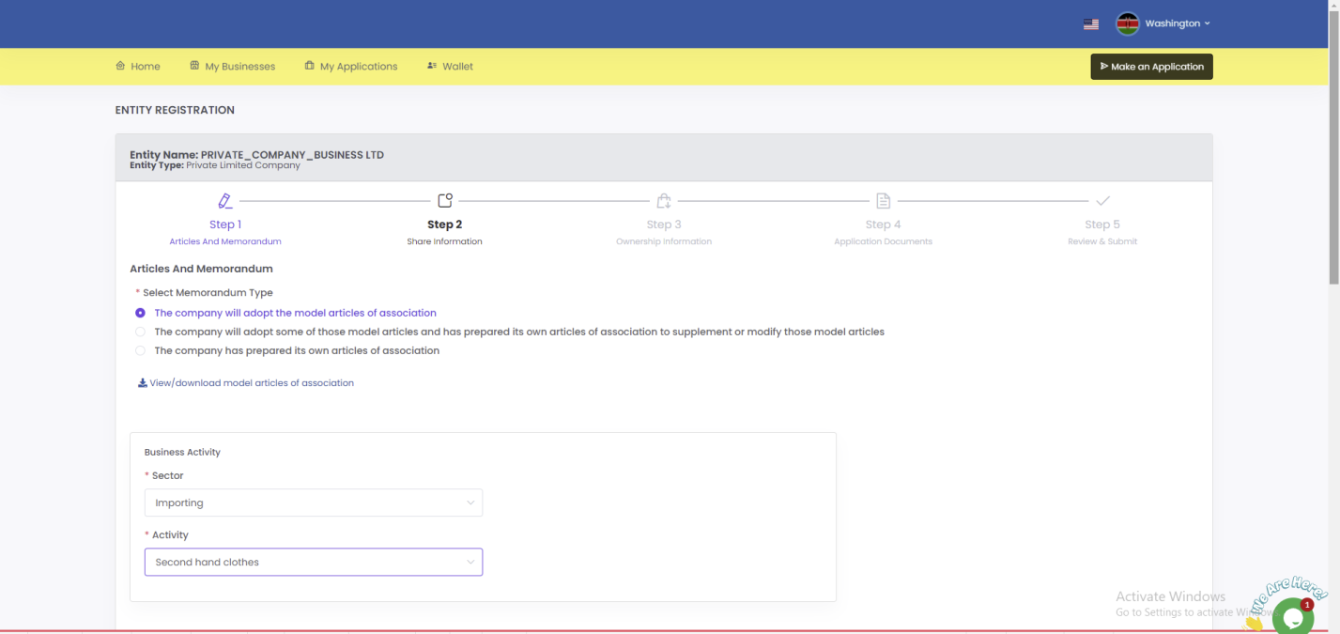
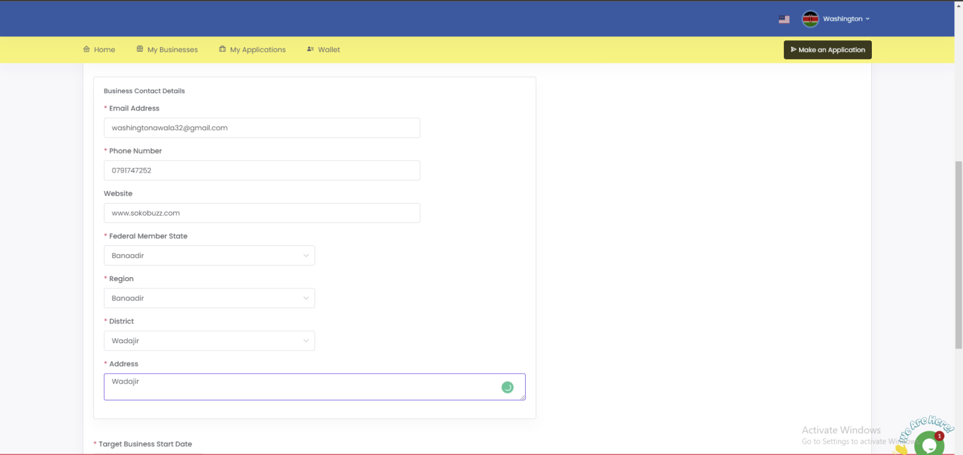
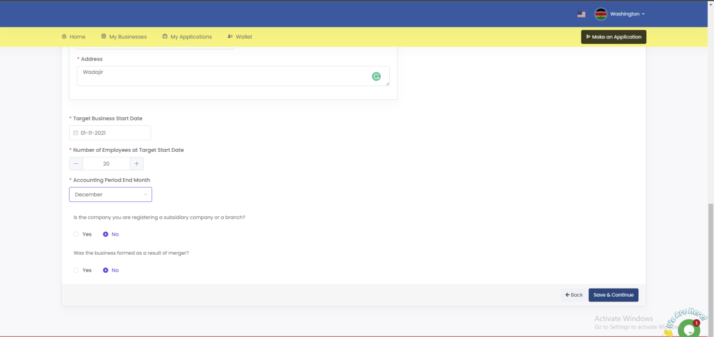

5. In Step 2 (Share information) clicks add new category, enter share information type, number of shares and nominal value then click save and continue.
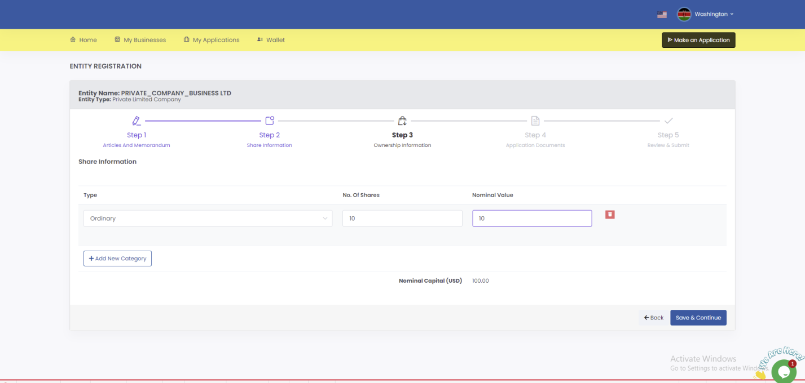

6. In Step 3(Ownership information) click add new official, on the modal that pops up, select official type, search for the official using their email address, select role allocate shares then click submit.

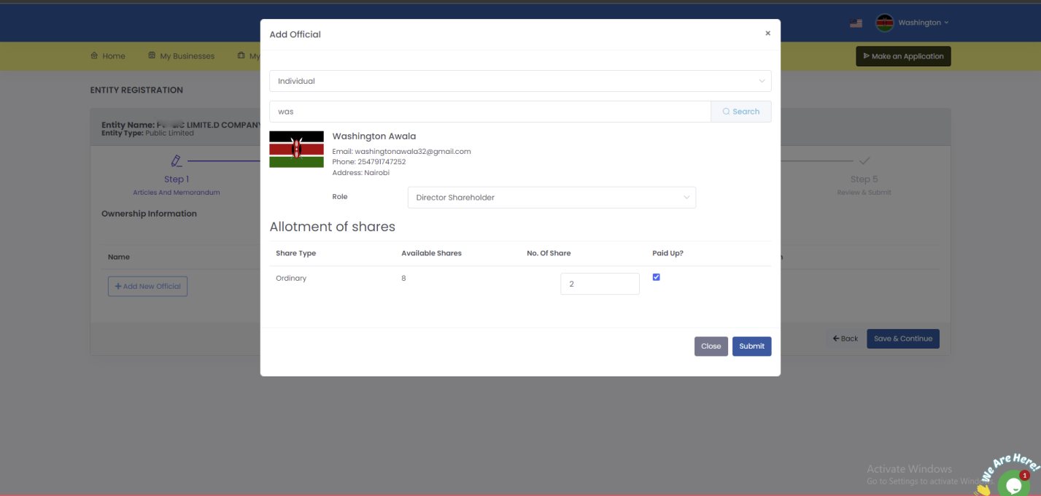

7. Click save and continue.
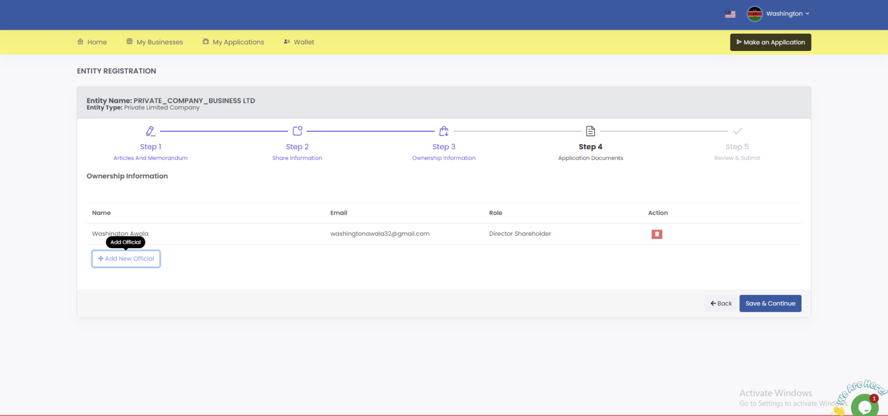

6. In Step 4(Application documents) upload model memorandum for company with share capital, upload Company Registration Form, upload notary then click save and continue
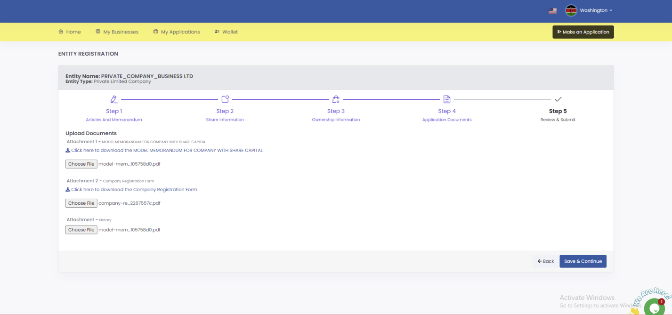

8. In Step 5(Review and submit) review the information; confirm that you have provided all the required documents then click submit.
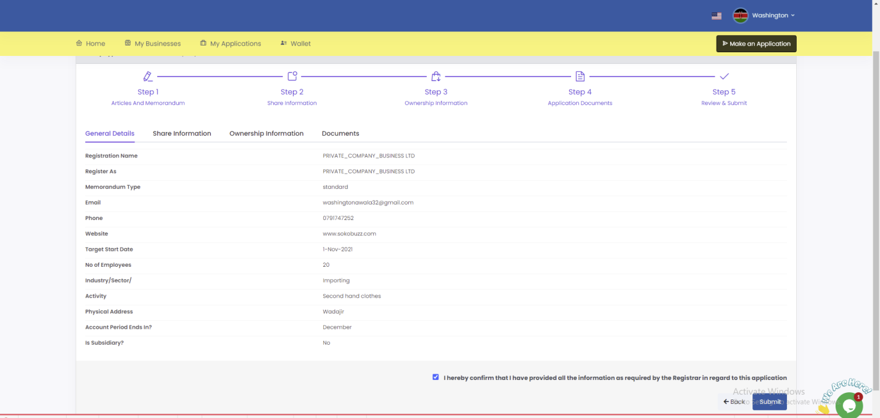

9. Click pay from wallet to pay the necessary charges.
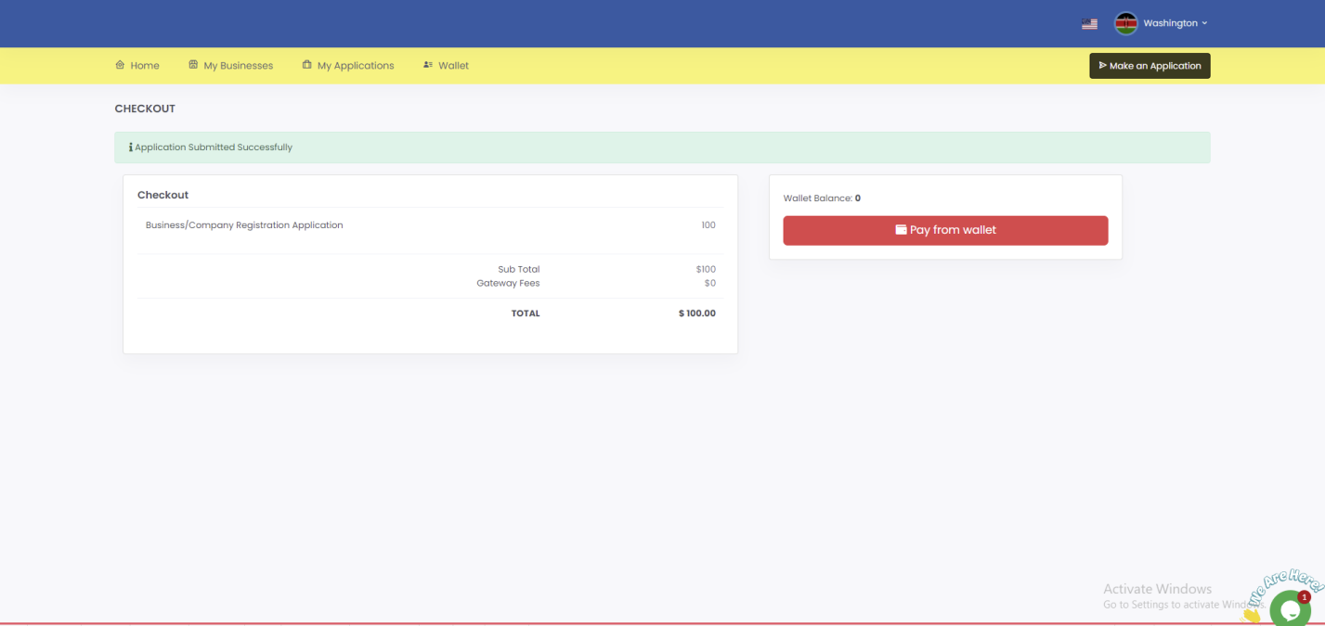

10. Once payment is successful you will see this page.
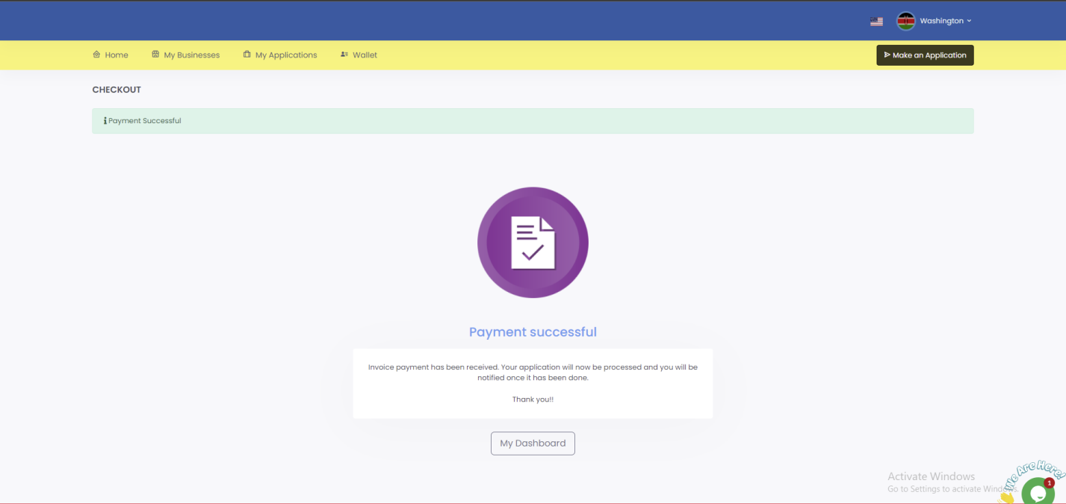

You will be required to keep checking your SBRL account to find out whether your business has been registered. Usually, it takes 1 business day.

