WALLET TOP UP USER MANUAL

AUTHOR LEVIS KIMATHI KARWIRWA

Purpose
The purpose of this document is to provide a visual guide on how to top up your SBRL account wallet.
Prerequisites
Individual submitting a request must have an SBRL account.
An account on one of the major banks of Somalia.

Steps of top up:
1. Log into your SBRL account (ebusiness.gov.so) as illustrated below fill in your credentials and click Sign In
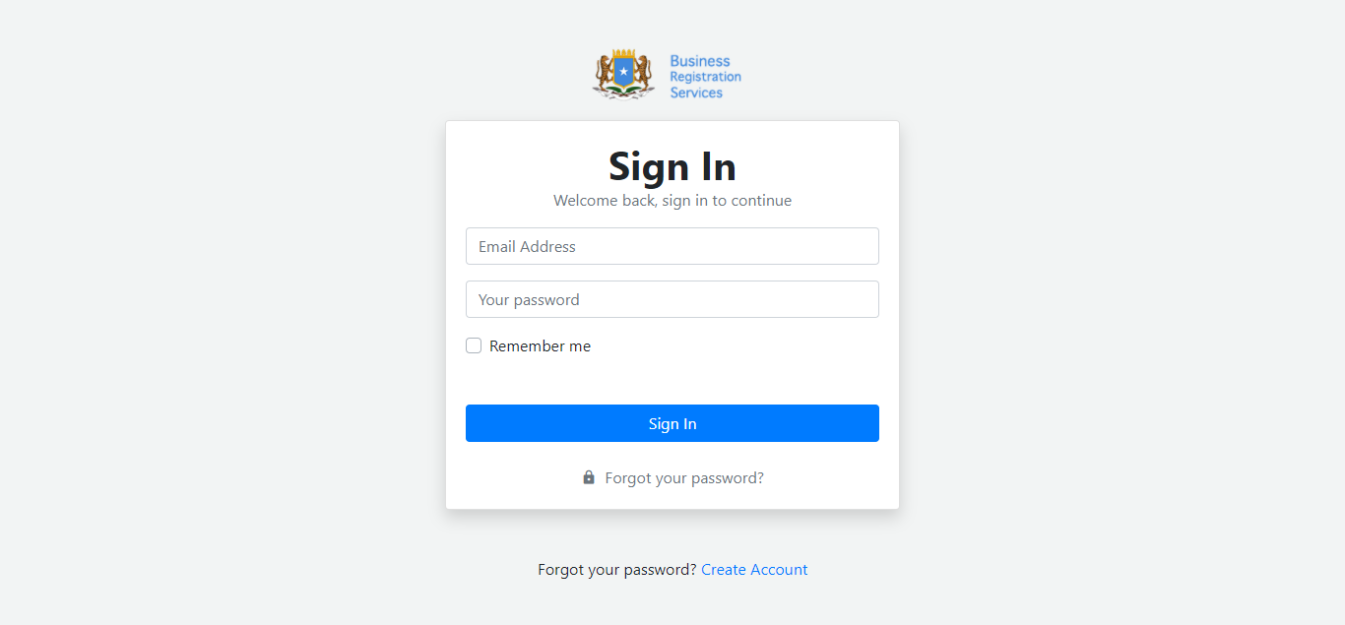

2. Click on Wallet at the top menu.
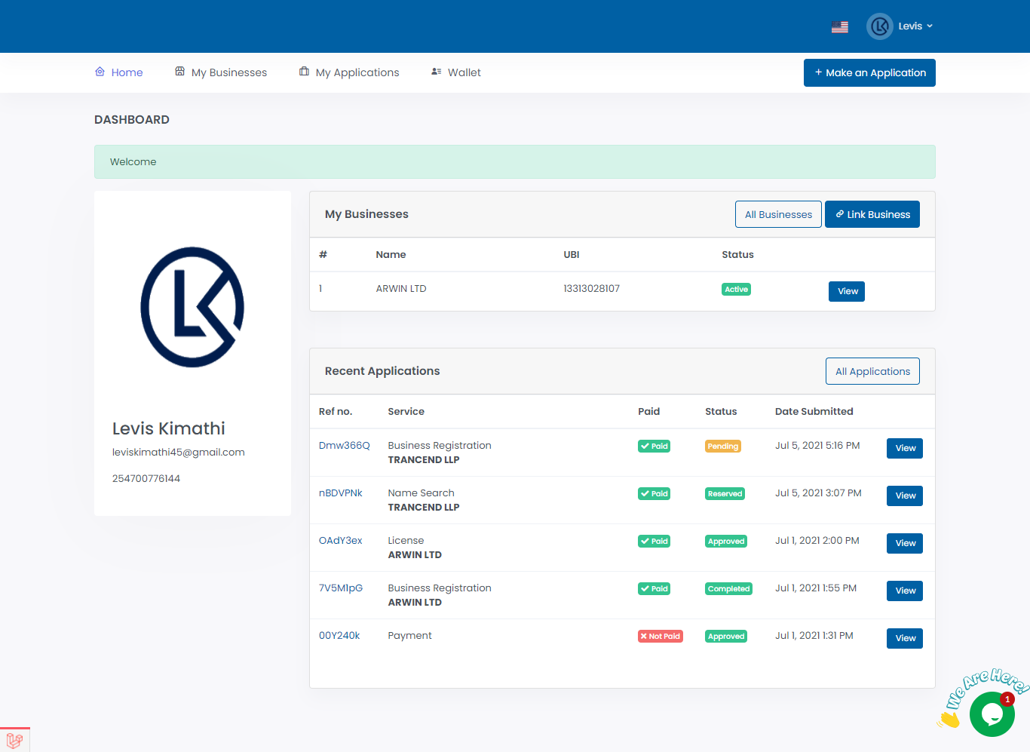

3. Click on Add Funds
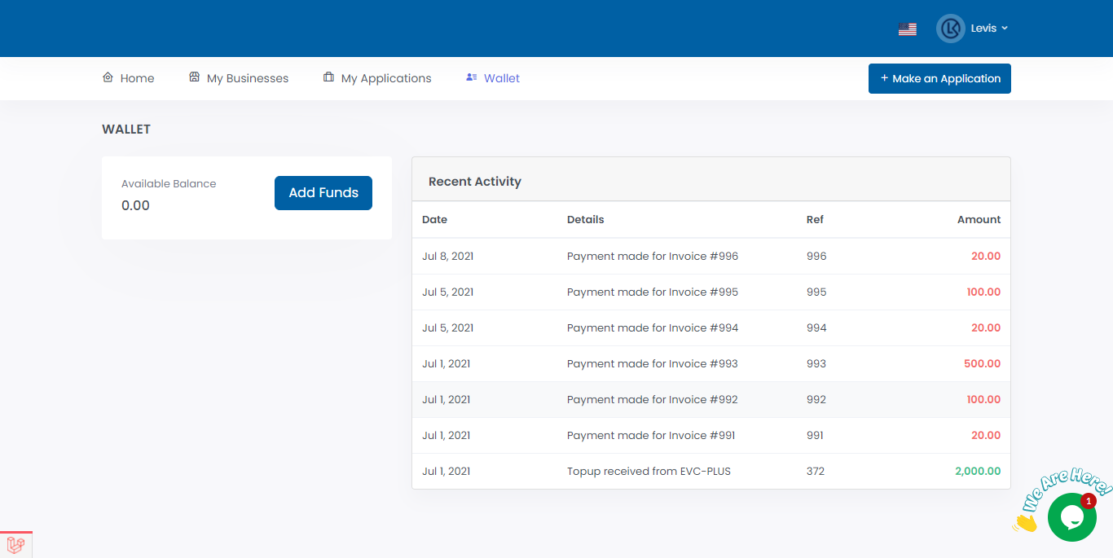

4. Choose the Payment Method you used then fill the relevant details regarding your payment i.e Amount, Date, Reference and click Submit.
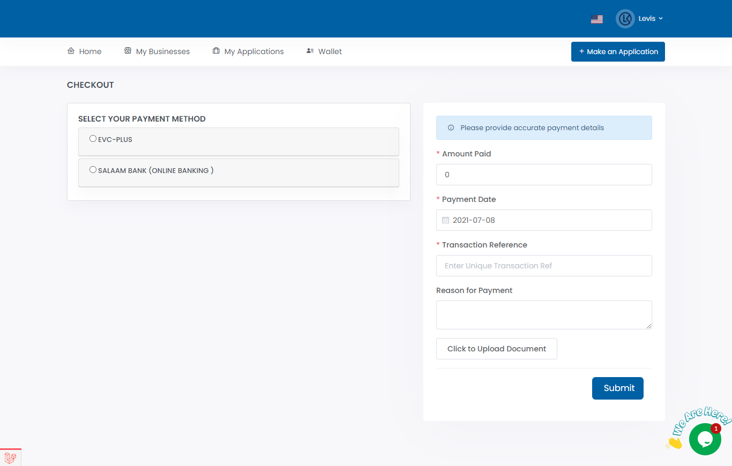

5. Once your Payment Request has been Submitted Successfully you will see the page below.

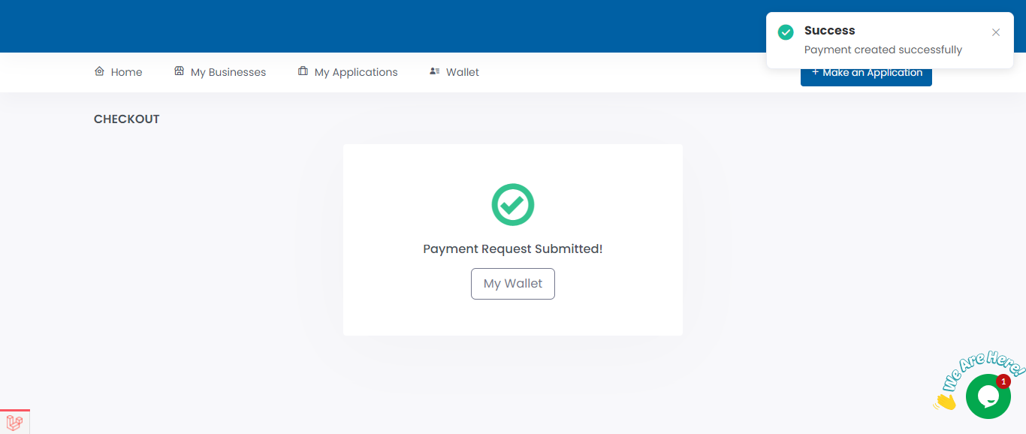

You will be required to keep checking your SBRL account to find out whether your Top Up was Approved or Rejected. Usually, it takes 1 business day. It should be noted that there is no requirement for a minimum or maximum number of Top Ups that can be done.

Circumstances in which a Payment Request will be rejected.
1. False payment details.
2. Vulgar or offensive words on the payment description.

